Prayer Requests
Members: William Angel, Michael Boerg, Judy Byerly, Shirley Byerly, Taylor Carroll, Kathy Davis, Nancy Davis, Anna Frances and Alden Dull, Corky Flowers, Phyllis and Riff Footland, Ruth Freeman, Rev. Don Griffin, John Harrold, Jean and Harvey Lunsford, Carolyn and Ken Neal, Penny Ratermann, Sandy Smith, Linda Tuttle, Cleo Willard-Weems.
Friends: Barbara Black (mother of Teresa Krause), Tiffany Dodson (daughter to Jeanne Willard), Susie Marion (friend of Pam Tatum).
Military: Jordan Hailey (Navy – son of Jerry Hailey), Daniel Millikan (Army – son of Dianne & Alan Millikan), Jeremiah Millikan (Navy – son of Dianne & Alan), Christian Nixon (National Guard – nephew of Candice & Rod Back), Eric Tise (grandson of Lindsay Tise).

Staff
Interim Pastor: Dr. Steve Martin
336-462-1085—stephendmartin88@gmail.com

Administrative Assistant: Patricia Rau

patricia@fairviewmoravianchurch.org

336-768-5629

Choir/Band Director: Van Krause
Organist: Martha Evans
Facilities Manager: Bill Wright

Church Board 2026
Elders: Beth Passmore, Vice Chair
Karen Blanton – Betsy Fowler- Eugenia Ivy –
Bill Shields, Gwen Shields
Trustees: Melissa Thompson, Chair
Dick Joyce – Alan Millikan – Barry Self – Rick Vaughan- Lynn Verona, Bill Wright

Oh, How He Loves You and Me
with “O, How I Love Jesus”

Words and Music by Kurt Kaiser; Arr. By Bruce Greer
© 1975 and this Arr. © 1985 Word Music (a div. of WORD, INC.)
Written by Frederick Whitfield, 1855

O, how I love Jesus, O, how I love Jesus,
O, how I love Jesus, because He first loved me!

Oh, how He loves you and me, Oh, how He loves you and me.
He gave his life, what more could He give?
Oh, how He loves you; Oh, how He loves me;
Oh, how He loves you and me.
Jesus to Calvary did go, His love for sinners to show.
What He did there brought hope from despair.
Oh, how He loves you; Oh, how He loves me;
Oh, how He loves you and me.

Oh, how He loves you and me, Oh, how he loves you and me.
He gave His life, what more could He give?

O, how I love Jesus, because He first loved me!

Oh, how He loves you and me.



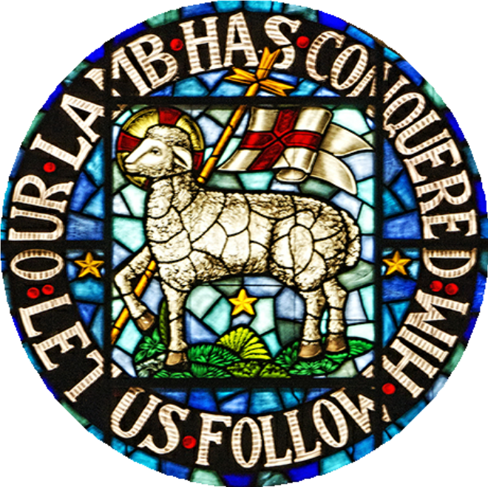

Fairview

Moravian Church

Established 1895

Watchword for Fairview
The precepts of the Lord are right, giving joy to the heart.
The commands of the Lord are radiant,
giving light to the eyes.
Psalm 19: 8

Fifth Sunday after Epiphany
February 8,2026—10:00a.m.


PRELUDE Oh, How He Loves You and Me

Martha Evans

TOLLING OF THE BELL

WORDS OF WELCOME AND ANNOUNCEMENTS Dr. Steve Martin

CALL TO WORSHIP

(inspired from Psalm 42, 43)

READER: Come, you whose souls thirst for the living.

PEOPLE: As the deer pants for the waters, so our souls pant for you, O God.

READER: Come, you who are burdened with grief and oppression.

PEOPLE: We come to you with all of our doubts, wounds and fears.

READER: Come, you who are in need of the good news.

PEOPLE: We come again in search of joy, truth and light.

READER: Come, you who find refuge in God, our rock and salvation.

ALL: Let our hope be found in God, for we shall praise the name of our God. AMEN.

HYMN OF CELEBRATION #635
We Are Called to Be God’s People

INVOCATION

LITURGY: SPIRITUAL RENEWAL #95

GIVING OF TITHES AND OFFERINGS

OFFERTORY PRAYER

ANTHEM He is Lord of All Fettke
Shawnee Press 1995 CCLI License #751334

DOXOLOGY
Praise God, from whom all blessings flow; praise him, all creatures here below; praise him above, ye heav'nly host; praise Father, Son,
and Holy Ghost! Amen.

INTRODUCTION OF GUEST SPEAKER

Bill Shields

SCRIPTURE READING

Matthew 7: 24-29 - pg. # 788

MESSAGE “Disciple (ship)”

Rev. Dr. Michael Brown

CLOSING HYMN #719
Be Thou My Vision

BENEDICTION Dr. Martin

POSTLUDE Martha Evans

Please sign the Friendship Register at the end of your pew and pass it down. If you would like information about our activities or becoming a member of Fairview, please indicate your wish in the appropriate space.

Bible Study and Lunch: Wednesday, February 11th at Noon.

Reporting Church Council is next Sunday, February 15th, immediately following our worship service.

The Music and Worship Committee will meet on Monday, February 16th at 5:30p.m. in the Conference Room.

Ash Wednesday Service - February 18th at 7:00p.m.

Jt. Bd. Meeting – February 9th at 5:30p.m. in the Conference Room.

2026 Day of Prayer Services
Ash Wednesday, February 18 – Home Moravian Church
The Rev. Virginia Tobiassen
10:00a.m. Coffee Hour; 10:45a.m. Music; 11:00a.m; Worship

Sunday, February 22 – Christ Moravian Church
The Rev. Linda Seipple, 1:30p.m. Band Prelude; 2:00p.m. Lovefeast,

Wednesday, February 25 – Trinity Moravian Church
The Rev. Craig Atwood, 11:00a.m. Worship; Complimentary Luncheon

Wednesday, March 4 – Ardmore Moravian Church
The Rev. Craig Troutman, 10:00a.m. Refreshments; 11:00a.m. Worship

Wednesday, March 11 – Fries Moravian Church
The Rev. Angelica Regalado-Cieza,
10:00a.m. Coffee Hour; 11:00a.m. Worship

Wednesday, March 18 – Fairview Moravian Church
The Rev. James Newsome, 10:15a.m. Band Prelude; 11:00a.m. Worship with Communion

Wednesday, March 25 – Konnoak Hills Moravian Church
The Rev. Judy Knopf, 11:00a.m. Lovefeast

