Welcome to Fairview Moravian Church Second Sunday in Advent
December 7, 2025
Please take a moment to sign the friendship pad in your pew.
Watchword for the week: Repent, for the kingdom of heaven has come near. Matthew 3: 2

Prelude Martha Evans
Tolling of the Bell
Welcome and Announcements Kathy Davis

Advent Wreath Candle Lighting Cynthia Faircloth and Bill Wright

Music for Reflection O Come, O Come, Immanuel
Candle Lighting

This morning, we light the two candles, the candle of hope and the candle of peace. This candle reminds us that Christ came into our world to restore peace, and that only through trust in God’s word and His promises can we find our own inner peace. We remember that Christ is the Prince of Peace who taught us that through simple acts of love and forgiveness peace is spread throughout the world.

Closing Prayer

Gracious God, as we continue our Advent journey, we thank you for sending the prince of Peace into a world filled with unrest and strife. We ask that you quiet our restless hearts and instill in each of us the calm assurance that tells us that you are in control so we need not worry. Give us the tools we need to serve as you would have us serve, and make us willing instruments of your peace. Amen.

Liturgy: Advent 2, page 54 Kathy Davis

Giving of Tithes and Offerings to the Lord Melissa Thompson
Prayer of Dedication
Anthem Shepherd’s Carol Ruth Elaine Schram
Harold Flammer Music 2004 CCLI License #751334
Doxology Praise God from Whom All Blessings Flow OLD 100TH
Praise God from whom all blessings flow;
Praise him, all creatures here below;
Praise him above, ye heavenly host;
Praise Father, Son, and Holy Ghost. Amen!

Reading of God’s Word Melissa Thompson
Isaiah 11: 1-10 (page 558), Romans 15: 4-13 (page 924)

Prayers of the People/Pastoral Prayer Melissa Thompson
Sermon Rev. Wayne Byerly
He Became Flesh
John 1: 14 (page 862)

Hymn 771 My Hope Is Built on Nothing Less

Benediction and Postlude 
We warmly welcome Rev. Wayne Byerly as our guest speaker this morning.

Our Church Family Prayer List: William Angel, Michael Boerg, Judy Byerly, Shirley Byerly, Nancy Davis, Anna Frances and Alden Dull, Corky Flowers, Phyllis and Riff Footland, Ruth Freeman and family, Rev. Don Griffin, John Harrold, Jean and Harvey Lunsford, Penny Ratermann, Sandy Smith, Pam Tatum, Cleo Willard-Weems.
Friends and Family Prayer List: Brian Ashley (brother of Karen Blanton), Travis Jackson family (friends of Pam Tatum), Cindy Logan (cousin to Pam Tatum), Wayne Miller (friend of Pam Tatum), the Southerland family, the Swaim family, the Tise family.
Our Military Prayer List: Jordan Hailey (Navy – son of Jerry Hailey), Daniel Millikan (Army – son of Dianne & Alan Millikan), Jeremiah Millikan (Navy – son of Dianne & Alan), Christian Nixon (National Guard – nephew of Candice & Rod Back), Eric Tise (grandson of Lindsay Tise).

The General Fund has received gifts in memory of Lindsay Tise from the Women’s Fellowship; in memory of Betty Stevenson from Bobby Bennett; in memory of Everett Freeman from WF Circle 1. The Building and Grounds Fund has received a gift in memory of Lindsay Tise and Everett Freeman from Gwen and Bill Shields. The Choir Fund has received a gift in memory of Lindsay Tise and Everett Freeman from Mollie and Robert Rascoe.

Sunday’s Worship Attendance: 75
Pledges/Offerings/Gifts/Other for November 30 $ 25,801.00
Monthly Budget Needs $ 35,544.75
Monies Received Month to Date 39,456.00
Overage as of November 30 $ 3,911.25+



Please Join Us for Our
Christmas Candlelight & Lovefeast Services

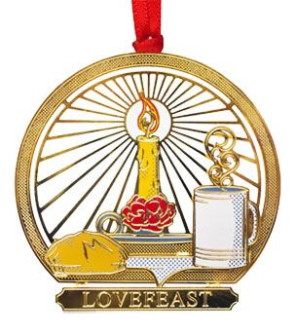
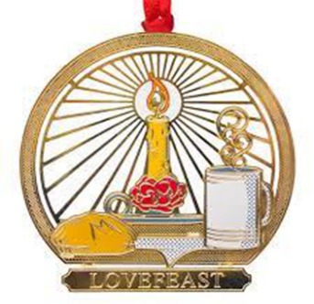
Sunday, December 21st at 10:00a.m. (no band prelude) and
Wednesday, December 24that 2:00 p.m.
band prelude 1:20p.m.

Fairview Moravian Church

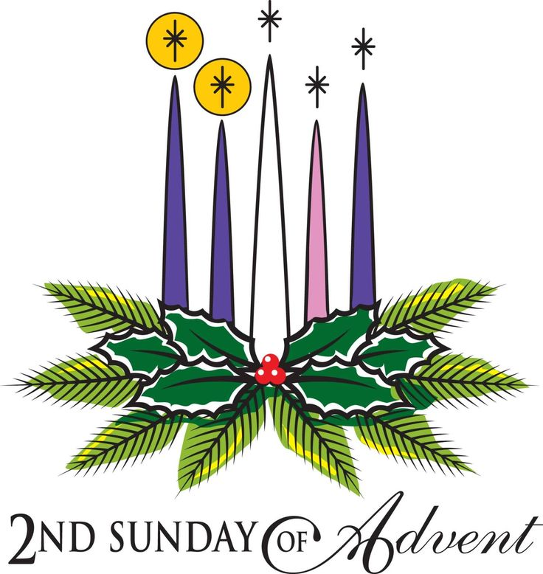

6550 Silas Creek Parkway
Winston-Salem, NC 27106

336-768-5629

www.fairviewmoravianchurch.org

Watchword for 2025

The Lord went in front of them in a pillar of cloud by day, to lead them along the way, and in a pillar of fire by night, to give them light.

Exodus 13: 21

CHURCH COUNCIL ELECTIONS
Today – 11:10 a.m.

Fairview’s Annual Church Council will convene in the Sanctuary today following our 10:00a.m. worship service. All communicant members of the congregation are encouraged to attend. If you would like to nominate an individual from the floor, please make sure you have their permission to do so. The Nominating Committee members are: Dick Joyce, Beth Passmore, Jane and Walt Schorer, Robert Rascoe and Doris Bostian present the following slate:

Board of Elders – for a term of 3-years (need two)

Robert Rascoe
Betsy Fowler

Board of Trustees – for a term of 3-years (need two)

Melissa Thompson
Alan Millikan

Synod

Dick Joyce
Robert Rascoe
Beth Passmore-alternate

CHAPTER III
CONGREGATIONAL COUNCIL
Article 3. November Council

It shall be the duty of the November Council to elect delegates to the Provincial Synod, and the members of the Boards of Elders and Trustees, and all other officers and boards of the church not otherwise provided for. Board members elected at Council shall assume office on January 1st following the November Council. Any matter relating to the temporal or spiritual welfare of the congregation may be discussed at the November Council.

Calendar Reminders:
Prayer Shawl Group – 2nd Monday of every month at 10:00a.m. (P)
Women’s Bible Study – Every Tuesday at 11:00a.m. (CR)
Choir Rehearsal - Wednesday’s at 5:30p.m. (S)
Men’s Bible Study – Every Thursday at 8:00a.m. (Mama Zoes)
Clothes Closet Open - First Saturday of each month at 8:00a.m.
WF Food Drive – 2nd Saturday of every month from 11:00a.m. to Noon
We encourage you to bring your donations to the church whenever it is convenient.
WF Circle Meetings:
WF#1- First Wednesday at 10:00a.m., WF#2- First Wednesday at 10:30a.m., WF#3- Third Tuesday at 5:30p.m., WF#4- First Tuesday at 10:30a.m.
Jt. Board Meeting – Monday, December 8th at 5:30p.m. (CR)

We have several flower openings in the coming months. Please call Cynthia Faircloth at 336-731-4687 if you would like to place flowers in the sanctuary on Sunday mornings in honor or memory of a loved one.

Moravian New Year’s Eve Watchnight Service
December 31, 2025 at 8:00 p.m.
St. Philips Moravian Church

All are invited to share a Watchnight Service sponsored by the Southern Province of the Moravian Church on Wednesday, December 31, at 8:00p.m. Band prelude 30 minutes prior to the service. This one-hour service of Holy Communion will be shared at St. Philips Moravian Church in the Salem Historic District (911 S. Church Street, Winston-Salem). Angelica Regalado-Cieza, pastor of Fries Memorial Moravian Church will speak.

