Welcome to Fairview Moravian Church First Sunday after Christmas
December 28, 2025
Please take a moment to sign the friendship pad in your pew.

Watchword for the week: I will recount the gracious deeds of the Lord, the praiseworthy acts of the Lord, because of all that the Lord has done for us. Isaiah 63: 7

Prelude Joy to the World arr. Wilson
Chi Chi Messick, Organist
Tolling of the Bell

Welcome and Announcements Bill Shields

Hymn 290 The First Noel

Liturgy: Christmas, page 59 Bill Shields

Giving of Tithes and Offerings to the Lord Melissa Thompson
Prayer of Dedication
Offertory Away in a Manger arr. Lau
CCLI License #751334

Doxology Praise God from Whom All Blessings Flow OLD 100TH
Praise God from whom all blessings flow;
Praise him, all creatures here below;
Praise him above, ye heavenly host;
Praise Father, Son, and Holy Ghost. Amen.

Prayers of the People/Pastoral Prayer Melissa Thompson

Reading of God’s Word Melissa Thompson
Psalm 147 (page 507)
Galatians 3: 23-25; 4: 4-7 (page 947)

Sermon “The Word Became Flesh” Br. Dick Joyce
John 1: 1-18 (page 862)

Hymn 292 Once in Royal David’s City

Benediction
Postlude Break Forth, O Beauteous, Heavenly Light Bach
Thank you to Chi Chi Messick for being our guest organist while Martha is on vacation.
Thank you to Br. Dick Joyce for bringing our message this morning.

Thank you to my Fairview family for all the support you gave me and my family during Everett's illness, death and memorial. You called, you sent cards, food, prayers and thoughts. You came to support me. You cooked, you planned, you served. -- ALL IN LOVE. Our Family appreciates all you have given in this difficult time for us. Ruth Freeman

The General Fund has received a gift in memory of Everett Freeman from Jane and Walt Schorer; in memory of Mary and Glenn Berger from Connie and Robert Price.

Sunday’s Worship Attendance on December 14: 84
Sunday’s Lovefeast and Candle Service on December 21: 127
Monthly Budget Needs $ 33,360.59
Monies Received Month to Date 46,198.56
Needed as of December 14 $ 12,837.97+

Our Church Family Prayer List: William Angel, Michael Boerg, Judy Byerly, Shirley Byerly, Nancy Davis, Anna Frances and Alden Dull, Corky Flowers, Riff Footland, Ruth Freeman and family, Rev. Don Griffin, John Harrold, Jean and Harvey Lunsford, Penny Ratermann, Sandy Smith, Cleo Willard-Weems.
Friends and Family Prayer List: Brian Ashley (brother of Karen Blanton), Tiffany Dodson (daughter of Jeanne Willard), the Family of Scott Draughn (friends of Pam Tatum), the Family of Steve Hicks (friends of Pam Tatum), the Family of Lindsay Tise.
Our Military Prayer List: Jordan Hailey (Navy – son of Jerry Hailey), Daniel Millikan (Army – son of Dianne & Alan Millikan), Jeremiah Millikan (Navy – son of Dianne & Alan), Christian Nixon (National Guard – nephew of Candice & Rod Back), Eric Tise (grandson of Lindsay Tise).

Calendar Reminders:
Prayer Shawl Group – 2nd Monday of every month at 10:00a.m. (P)
Women’s Bible Study – Every Tuesday at 11:00a.m. (CR)
Choir Rehearsal - Wednesday’s at 5:30p.m. (S) No Choir Rehearsal on 12/31
Men’s Bible Study – Every Thursday at 8:00a.m. (Mama Zoes) No BS on 1/1
Clothes Closet Open - First Saturday of each month at 8:00a.m.
WF Food Drive – 2nd Saturday of every month from 11:00a.m. to Noon
We encourage you to bring your donations to the church whenever it is convenient.
WF Circle Meetings:
WF#1- First Wednesday at 10:00a.m., WF#2- First Wednesday at 10:30a.m., WF#3- Third Tuesday at 5:30p.m., WF#4- First Tuesday at 10:30a.m.

Moravian New Year’s Eve Watchnight Service
December 31, 2025 at 8:00 p.m.
St. Philips Moravian Church

All are invited to share a Watchnight Service sponsored by the Southern Province of the Moravian Church on Wednesday, December 31, at 8:00p.m. Band prelude 30 minutes prior to the service. This one-hour service of Holy Communion will be shared at St. Philips Moravian Church in the Salem Historic District (911 S. Church Street, Winston-Salem). Angelica Regalado-Cieza, pastor of Fries Memorial Moravian Church will speak.

The Southern Province is participating in the worldwide Moravian Church Unity Prayer Watch in 2026. Fairview will take part in this prayerful tradition between Midnight and 8:00a.m. on Saturday, January 10, 2026. We have several time slots available. The signup sheet and prayer topic copies are in the parlor.

The 2026 Offering Books are ready to be picked up in the Parlor. Please start using your new envelopes on January 1st. You may not have the same envelope number as you did in 2025.

The 2026 Fairview Church Directory will be published in January. If you have new contact information, please call Patricia at 336-768-5629 or email patricia@fairviewmoravianchurch.org within the next week to let her know. Thanks!

Are you looking for a mid-week spiritual recharge? Look no further! Mark your calendars for Wednesday, January 7, 2026, at Noon, as we host our Wednesday Lunch and Bible Study. Br. Bill Shields will be leading our discussion, bringing his unique perspective and passion to our study of the scriptures. This is an open-door event, and we strongly encourage you to bring along a friend, a neighbor, or a family member to share in the food and the inspiration. Whether you are a lifelong scholar of the Bible or just curious about what the Word has to say, there is a place for you here. Let’s grow in faith and share a wonderful meal together.

We have several flower openings in the coming months. Please call Cynthia Faircloth at 336-731-4687 if you would like to place flowers in the sanctuary on Sunday mornings in honor or memory of a loved one.

Fairview Moravian Church

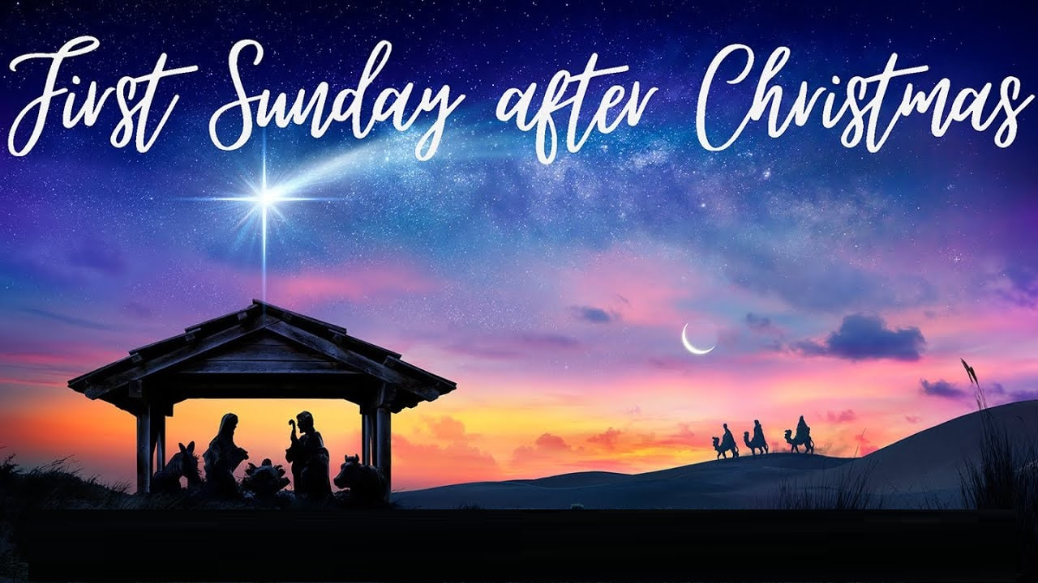

Fairview Moravian Church
6550 Silas Creek Parkway
Winston-Salem, NC 27106

336-768-5629

www.fairviewmoravianchurch.org

Watchword for 2025

The Lord went in front of them in a pillar of cloud by day, to lead them along the way, and in a pillar of fire by night, to give them light.

Exodus 13: 21

