Welcome to Fairview Moravian Church Third Sunday in Advent
December 14, 2025
Please take a moment to sign the friendship pad in your pew.
Watchword for the week: Be strong, do not fear! Here is your God! Isaiah 35: 4

Prelude Ms. Martha Evans
Tolling of the Bell
Welcome and Announcements Mr. Bill Shields

Advent Wreath Candle Lighting

Ms. Kathy Davis, Mr. Thad Carter, Mrs. Kristen Hailey

Music for Reflection O Come, O Come, Immanuel
Candle Lighting

This morning, we light three candles, the candles of hope, peace and today, joy. This candle reminds us that we have a reason to be joyful, even in the midst of strife. We remember that the angel proclaimed Christ’s birth as “Good news of great joy, to all people.” We celebrate today with joyful hearts and commit ourselves to spreading that joy to the world around us.

Closing Prayer

Gracious God, as we continue our Advent journey, we ask that you open our eyes to the beauty and goodness around us, and fill our hearts with grateful joy. Remind us that Christ is our light and the source of all joy, and that we are here to serve you and to spread that joy to others. Amen.

Liturgy: Joy Through Clothing Those in Need, insert Mr. Barry Self

Giving of Tithes and Offerings to the Lord Mr. Barry Self
Prayer of Dedication
Anthem What Did the Star See?
Paul Williams and Joseph Martin
Shawnee Press 1994 CCLI License #751334
Doxology Praise God from Whom All Blessings Flow OLD 100TH
Praise God from whom all blessings flow;
Praise him, all creatures here below;
Praise him above, ye heavenly host;
Praise Father, Son, and Holy Ghost. Amen!

Reading of God’s Word Ms. Melissa Thompson
Isaiah 35: 1-10 (page 578)
Psalm 146: 5-10 (page 507)
Matthew 11: 2-11 (page 792)

Prayers of the People/Pastoral Prayer Ms. Melissa Thompson
Sermon Mr. Bill Shields
Endless Joys of Christ
Luke 2: 8-20 (page 833)

Hymn 295 Hark! The Herald Angels Sing

Benediction and Postlude 
We warmly welcome Mr. Bill Shields as our guest speaker this morning.

Our Church Family Prayer List: William Angel, Michael Boerg, Judy Byerly, Shirley Byerly, Nancy Davis, Anna Frances and Alden Dull, Corky Flowers, Riff Footland, Ruth Freeman and family, Rev. Don Griffin, John Harrold, Jean and Harvey Lunsford, Penny Ratermann, Sandy Smith, Pam Tatum, Cleo Willard-Weems.
Friends and Family Prayer List: Brian Ashley (brother of Karen Blanton), Tiffany Dodson (daughter of Jeanne Willard).
Our Military Prayer List: Jordan Hailey (Navy – son of Jerry Hailey), Daniel Millikan (Army – son of Dianne & Alan Millikan), Jeremiah Millikan (Navy – son of Dianne & Alan), Christian Nixon (National Guard – nephew of Candice & Rod Back), Eric Tise (grandson of Lindsay Tise).

My heartfelt thanks to my church family for your support during my recent surgery and recovery. The cards, calls, food, and kindness have meant the world to me. I love you all and appreciate you more than words can say! Corky Flowers

The Repair/Reserve Fund has received a gift in memory of Everett Freeman from Melissa Thompson.
The Mobile Food Pantry has received gifts in memory of Lindsay Tise from Melissa Thompson; in memory Everett Freeman from Barry Self.
Sunday’s Worship Attendance: 84
Pledges/Offerings/Gifts/Other for December 7 $ 17,929.56
Monthly Budget Needs $ 35,544.75
Monies Received Month to Date 17,929.56
Needed as of December 7 $ 17,615.19



Please Join Us for Our
Christmas Candlelight & Lovefeast Services

Sunday, December 21st at 10:00a.m. (no band prelude)
Wednesday, December 24that 2:00 p.m.
band prelude 1:20p.m.

On Wednesday, December 14, Fairview provided a Lovefeast presentation and candle craft activity for 135 4th grade students at Speas Elementary School. The students enjoyed the craft, the presentation, and the chance to enjoy lemonade and ginger cookies! Special thanks go to Sandy Smith and Mary Cannon, friends of Fairview Angela Tuttle and Becky Robertson, and Fred McKinney (guitarist and sound) for all of their help during the Speas presentation, as well as with set-up and clean-up. Thanks to Lynn Verona for making over 150 candle craft kits! We also want to thank Mrs. Hanes Moravian Cookies for donating the ginger cookies for our Lovefeast. We appreciate everyone’s help in making this event a success.

Advent-Hopewell Band Concert-Tuesday, December 16th at 7p.m. in
the Saal at Salemtowne.

Fairview Moravian Church

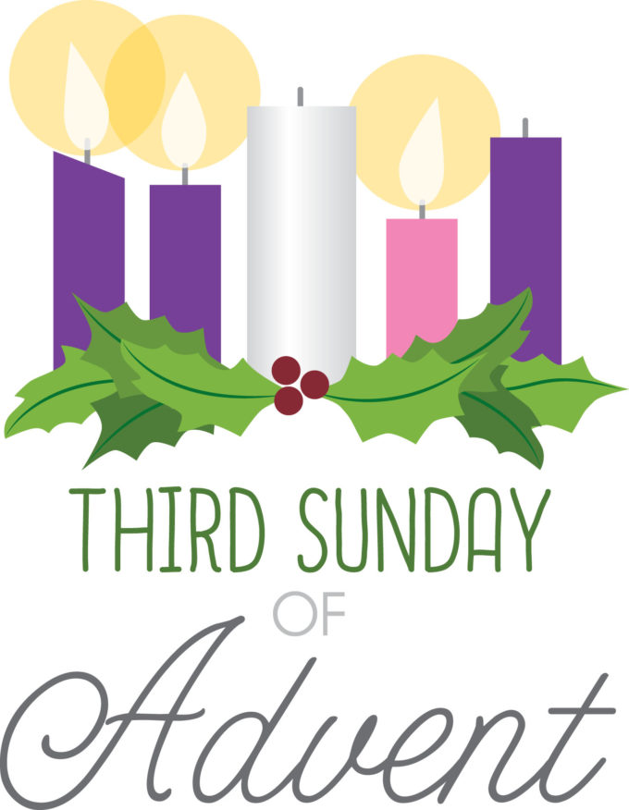

6550 Silas Creek Parkway
Winston-Salem, NC 27106

336-768-5629

www.fairviewmoravianchurch.org

Watchword for 2025

The Lord went in front of them in a pillar of cloud by day, to lead them along the way, and in a pillar of fire by night, to give them light.

Exodus 13: 21

Calendar Reminders:
Prayer Shawl Group – 2nd Monday of every month at 10:00a.m. (P)
Women’s Bible Study – Every Tuesday at 11:00a.m. (CR)
Choir Rehearsal - Wednesday’s at 5:30p.m. (S)
Men’s Bible Study – Every Thursday at 8:00a.m. (Mama Zoes)
Clothes Closet Open - First Saturday of each month at 8:00a.m.
WF Food Drive – 2nd Saturday of every month from 11:00a.m. to Noon
We encourage you to bring your donations to the church whenever it is convenient.
WF Circle Meetings:
WF#1- First Wednesday at 10:00a.m., WF#2- First Wednesday at 10:30a.m., WF#3- Third Tuesday at 5:30p.m., WF#4- First Tuesday at 10:30a.m.

We have several flower openings in the coming months. Please call Cynthia Faircloth at 336-731-4687 if you would like to place flowers in the sanctuary on Sunday mornings in honor or memory of a loved one.

Moravian New Year’s Eve Watchnight Service
December 31, 2025 at 8:00 p.m.
St. Philips Moravian Church

All are invited to share a Watchnight Service sponsored by the Southern Province of the Moravian Church on Wednesday, December 31, at 8:00p.m. Band prelude 30 minutes prior to the service. This one-hour service of Holy Communion will be shared at St. Philips Moravian Church in the Salem Historic District (911 S. Church Street, Winston-Salem). Angelica Regalado-Cieza, pastor of Fries Memorial Moravian Church will speak.

Third Sunday of Advent
JOY Through Clothing Those in Need

On this third Sunday of Advent, as we anticipate the coming Christ Child, we lit the candle of hope, peace and joy.
We rejoice that in Jesus Christ, God is with us, Immanuel.

When Christ comes into our lives,
He brings the fullness of joy.

Jesus healed the lame, cleansed the leper, recovered sight to the blind and raised the dead. We are witnesses to what we have seen and heard.
Because we see what Jesus can do in the world, we can live every day in the joy of the Messiah.

When Moravian Academy in Bethlehem, Pennsylvania realized they had an abundance of school uniforms they partnered with Central Moravian Church and the Board of World Mission to ship them to Nicaragua and Honduras and share them with the children there.
We thank God for those who bring joy through clothing those in need.

Oak Grove Moravian Church in Winston-Salem, North Carolina has been partnering with their neighborhood elementary for over a decade to help meet the needs of students and staff. This year they provided T-shirts for every student as part of their Community Teams Program.
We thank God for those who bring joy through clothing those in need.

Fairview Moravian Church's "Fairview Clothes Closet" is a ministry serving people in need of clothing within the community with love and dignity. The program aims to share warmth and joy through providing essential clothing items to those who require assistance.

We thank God for those who bring joy through clothing those in need.

In this time, our congregation celebrates the light of Joy in our community and through our shared ministry

(speak aloud the areas of ministry that provide clothing and basic needs in your community)

And all God’s children say:
We thank God for those who bring joy through clothing those in need.

Christ the Lord (page 64)
Christ the Lord, the Lord most glorious, now is born; O shout
a-loud! We by him are made victorious; praise the Savior, hail our God!
Praise the Lord, God, our salvation, praise him who re-trieved our loss; Sing, with awe, and love’s sensation, hal-le-lu-jah! God with us!
(Adapted from #298 in the Moravian Book of Worship, Text by John Miller 1789.
Used by permission of the Interprovincial Board of Communication.)

We pray today for all God’s children,
That each one might know the hope, peace, joy, and love that comes from God to the world through the advent of the Christ Child. Amen.

