Welcome to Fairview Moravian Church First Sunday in Advent
November 30, 2025
Please take a moment to sign the friendship pad in your pew.
Watchword for the week: Come, let us walk in the light of the Lord! Isaiah 2:5

Band Prelude
Call to Worship Coventry Carol Traditional
Welcome and Announcements Marshall Mathers
Prayers of the People/Pastoral Prayer Marshall Mathers

Candle Lighting Kierstyn, Lanny and Kevin Krause

Music for Reflection O Come, O Come, Immanuel
Candle Lighting

This morning, we light the first candle, the candle of hope. This candle reminds us that God's promises give us reason to be filled with hope; hope for unity in a world of division, hope for healing in a world of pain, and hope for peace in a world filled with anger and strife. We remember that Christ is our light and the source of our hope.
Closing Prayer

Gracious God, as we begin our Advent journey, we thank you for the gift of your Son, and for sending hope into a world filled with dread. Help us remember that we are your people, and because of your promises we have every reason to be hopeful. Take away our doubt and fear, and remind us that Christ is our light, and the true source of hope. Amen.

Liturgy: Advent 1, page 49, with Hosanna page 239 Marshall Mathers

Giving of Tithes and Offerings to the Lord Bill Shields
Prayer of Dedication
Anthem Hymn of Advent Lloyd Larson
Alfred Music 1998 CCLI License #751334
Doxology Praise God from Whom All Blessings Flow OLD 100TH
Praise God from whom all blessings flow;
Praise him, all creatures here below;
Praise him above, ye heavenly host;
Praise Father, Son, and Holy Ghost. Amen!

Reading of God’s Word Bill Shields
Isaiah 5: 1-5, Romans 13: 8-14, Matthew 24: 36-51

Sermon Rev. Steve Craver
The Right Question Brings the Right Answer

Hymn 256 Rejoice, Rejoice, Believers

Benediction Rev. Craver
Postlude Hosanna in the Highest Ellacombe

Fairview warmly welcomes the Rev. Steve Craver to our pulpit this morning. Rev. Craver is a retired Moravian pastor having served 36.5 years in various congregations in the Southern and Northern Provinces. Now Steve is a full-time woodworker and a very part-time pastor. He and his wife Jenny have been married 51 years and have two children, son Matthew, a robotics engineer and daughter Rebecca who is Moravian Minister. Steve and Jenny live in Durham. NC in a retirement community. Grandchildren brought them there.

The congregation was saddened by the loss of four of our members: Lindsay Tise on November 15th, Everett Freeman on November 20th, Shirley Southerland on November 22nd, and Eleanor Swaim on November 23rd. Please keep Lindsay, Everett, Shirley, and Eleanor’s families in your thoughts and prayers.

The Wreaths placed on the church doors are given to the Glory of God by the Women’s Fellowship.
The flowers in the sanctuary today are given to the glory of God.

Our Church Family Prayer List: William Angel, Michael Boerg, Judy Byerly, Shirley Byerly, Nancy Davis, Anna Frances and Alden Dull,
Phyllis and Riff Footland, Ruth Freeman and family, Rev. Don Griffin, John Harrold, Kaleb Krause, Jean and Harvey Lunsford, Penny Ratermann, Sandy Smith, Pam Tatum, Cleo Willard-Weems.
Friends and Family Prayer List: Travis Jackson family (friends of Pam Tatum), Cindy Logan (cousin to Pam Tatum), Wayne Miller (friend of Pam Tatum), the Southerland family, the Swaim family, the Tise family.
Our Military Prayer List: Jordan Hailey (Navy – son of Jerry Hailey), Daniel Millikan (Army – son of Dianne & Alan Millikan), Jeremiah Millikan (Navy – son of Dianne & Alan), Christian Nixon (National Guard – nephew of Candice & Rod Back), Eric Tise (grandson of Lindsay Tise).

Thank you to Chi Chi Messick for being our guest organist this morning!

The General Fund has received gifts in memory of Lindsay Tise from Doris Bostian, Barry Self, Sandy Smith, Patricia and Mike Rau and Dorcas and Ken Hauser; in memory of Everett Freeman from Sandy Smith and Patricia and Mike Rau; in memory of Thelma Fulp from Sandy Smith.

Sunday’s Worship Attendance: 85
Pledges/Offerings/Gifts/Other for November 23 $ 1,741.00
Monthly Budget Needs $ 35,544.75
Monies Received Month to Date 13,655.00
Needed as of November 23 $ 21,889.75



Please Join Us for Our
Christmas Candlelight & Lovefeast Services

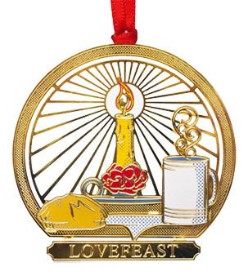

Sunday, December 21st at 10:00a.m. and
Wednesday, December 24that 2:00 p.m.

Fairview Moravian Church

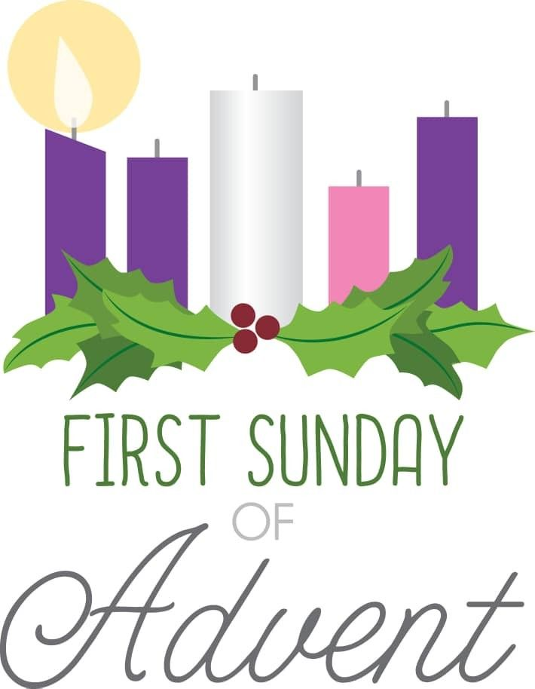

6550 Silas Creek Parkway
Winston-Salem, NC 27106

336-768-5629

www.fairviewmoravianchurch.org

Watchword for 2025

The Lord went in front of them in a pillar of cloud by day, to lead them along the way, and in a pillar of fire by night, to give them light.

Exodus 13: 21

CHURCH COUNCIL ELECTIONS
Sunday, December 7th – 11:10 a.m.

Fairview’s Annual Church Council will convene in the Sanctuary Sunday, December 7th, following the 10:00 a.m. worship service. All communicant members of the congregation are encouraged to attend. The Nominating Committee members are: Dick Joyce, Beth Passmore, Jane and Walt Schorer, Robert Rascoe and Doris Bostian present the following slate:

Board of Elders – for a term of 3-years (need two)

Robert Rascoe
Betsy Fowler

Board of Trustees – for a term of 3-years (need two)

Melissa Thompson
Alan Millikan

Synod

Dick Joyce
Robert Rascoe
Beth Passmore-alternate

CHAPTER III
CONGREGATIONAL COUNCIL
Article 3. November Council

It shall be the duty of the November Council to elect delegates to the Provincial Synod, and the members of the Boards of Elders and Trustees, and all other officers and boards of the church not otherwise provided for. Board members elected at Council shall assume office on January 1st following the November Council. Any matter relating to the temporal or spiritual welfare of the congregation may be discussed at the November Council.

Calendar Reminders:
Prayer Shawl Group – 2nd Monday of every month at 10:00a.m. (P)
Women’s Bible Study – Every Tuesday at 11:00a.m. (CR)
Choir Rehearsal - Wednesday’s at 5:30p.m. (S)
Men’s Bible Study – Every Thursday at 8:00a.m. (Mama Zoes)
Clothes Closet Open - First Saturday of each month at 8:00a.m.
WF Food Drive – 2nd Saturday of every month from 11:00a.m. to Noon
We encourage you to bring your donations to the church whenever it is convenient.
WF Circle Meetings:
WF#1- First Wednesday at 10:00a.m., WF#2- First Wednesday at 10:30a.m., WF#3- Third Tuesday at 5:30p.m., WF#4- First Tuesday at 10:30a.m.
WF Ladies Christmas Luncheon – Wednesday, December 3rd at Noon (FH)
Church Council – Sunday, December 7th, immediately following worship.
Jt. Board Meeting – Monday, December 8th at 5:30p.m. (CR)

We have several flower openings in the coming months. Please call Cynthia Faircloth at 336-731-4687 if you would like to place flowers in the sanctuary on Sunday mornings in honor or memory of a loved one.

Moravian New Year’s Eve Watchnight Service
December 31, 2025 at 8:00 p.m.
St. Philips Moravian Church
All are invited to share a Watchnight Service sponsored by the Southern Province of the Moravian Church on Wednesday, December 31, at 8:00 p.m. Band prelude 30 minutes prior to the service. This one-hour service of Holy Communion will be shared at St. Philips Moravian Church in the Salem Historic District (911 S. Church Street, Winston-Salem). Angelica Regalado-Cieza, pastor of Fries Memorial Moravian Church will speak.

