Welcome to Fairview Moravian Church All Saints Day
Commitment Sunday
November 2, 2025
Please take a moment to sign the friendship pad in your pew.
Watchword for the week: Jesus said, “For the son of man came seek and to save the lost.”
Luke 19: 10

Prelude

Tolling the Hour-10:00a.m.

Hymn 539 All People That on Earth Do Dwell

Welcome and Announcements Dick Joyce

Liturgy: All Saints, page 105

Liturgy: Service of Remembrance, Insert Bill Shields

Giving of Tithes and Offerings to the Lord
Prayer of Dedication
Offertory A Rushing Mighty Wind Lloyd Larson
Shawnee Press Inc. 2009 CCLI License #751334

Doxology Praise God from Whom All Blessings Flow OLD 100TH
Praise God from whom all blessings flow;
Praise him, all creatures here below;
Praise him above, ye heavenly host;
Praise Father, Son, and Holy Ghost.

Reading of God’s Word Melissa Thompson

1 Corinthians 3: 9, 2 Corinthians 9: 6-8, Psalm 100: 1-5

Prayers of the People/Pastoral Prayer

Sermon “A Way of Life” Ms. Laura Watson
Matthew 25: 31-46

Hymn 610 Take My Life That It May Be

Presentation of Stewardship Commitments
(In recognition of your personal relationship with Christ Jesus as Lord and Savior, we invite all to come forward. For those who use the commitment cards, please place your card face down in the basket. “When the people willingly offer themselves, Bless the Lord! Judges 5: 21)

Benediction

Postlude
The service concludes with the postlude; we hope you will stay to enjoy it!


In thanksgiving for the gift of eternal life, the chancel flowers are placed in the sanctuary today to the glory of God and in memory of our members who have passed to their heavenly reward.

Thank you to Ms. Laura Watson for being our guest speaker this morning! Laura is the Vice President and Director of the Moravian Ministries Foundation in America.

Sunday’s Worship Attendance: 81
Pledges/Offerings/Gifts/Other for October 26 $ 5,371.00
Monthly Budget Needs $ 35,544.75
Monies Received Month to Date 13,163.00
Needed as of October 26 $ 22,381.75

Reminders:
Prayer Shawl Group – 2nd Monday of every month at 10:00a.m. (P)
Women’s Bible Study – Every Tuesday at 11:00a.m. (Lot 63)
Lunch and Bible Study – Wednesday, November 5th and
November 19th at Noon (FH)
Choir Rehearsal - Wednesday’s at 5:30p.m. (S)
Men’s Bible Study – Every Thursday at 8:00a.m. (Mama Zoes)
Clothes Closet Open - First Saturday of each month at 8:00a.m.
WF Food Drive – 2nd Saturday of every month from 11:00a.m. to Noon
We encourage you to bring your donations to the church whenever it is convenient.
WF Circle Meetings:
WF#1- First Wednesday at 10:00a.m., WF#2- First Wednesday at 10:30a.m., WF#3- Third Tuesday at 5:30p.m., WF#4- First Tuesday at 10:30a.m.
Band Rehearsals – Today, November 2nd at 4:30p.m. (FH)
Candle Trim – Monday, November 10 at 10:00a.m. (FH)
Church Council – Sunday, December 7th, immediately following worship.

The Nominating Committee has been formed to prayerfully discern and select a slate of nominees for the Board of Elders and Board of Trustees. The election for these important leadership positions will be held during the Annual Church Council on Sunday, December 7th, immediately following the worship service. The members of this year's Nominating Committee are Beth Passmore, Dick Joyce, Jane and Walt Schorer, Robert Rascoe, and Doris Bostian.
We invite all members to consider serving and to contact any committee member if you feel God is leading you to participate in this ministry. Please continue to hold these positions and the committee in your prayers.

As our annual Stewardship season concludes, please submit your 2026 Pledge Card and Time and Talent Sheet during the final hymn in today's service. Your commitment is a direct reflection of our shared gratitude to God and our dedication to the future of our church. Afterward, we hope you will stay for our special catered luncheon to celebrate our mission together. Everyone is welcome!!!

Fairview Moravian Church

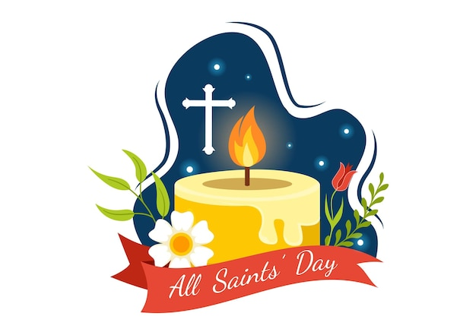

6550 Silas Creek Parkway
Winston-Salem, NC 27106

336-768-5629

www.fairviewmoravianchurch.org

Watchword for 2025

The Lord went in front of them in a pillar of cloud by day, to lead them along the way, and in a pillar of fire by night, to give them light.

Exodus 13: 21

Candle-Lighting Service of Remembrance

We gather this morning to celebrate the lives of persons we name as saints.

Some of the saints are living, others have completed their physical lives here on earth.

Some have touched us personally; others have touched and called into question the institutions and structures of our society.

But all have shaken our being – all have been examples of lives of wholeness, working for justice. We celebrate these persons and their lives in all aspects of God’s creation!

God of grace and glory, we come today to remember those in our church family who have entered into your more immediate presence during this year. As we remember those who have died and affirm that they are in God’s keeping, we light candles as an act of remembrance. We come to remember, especially before you today:

Dr. Kenneth Tomberlin

Sam Hardister

Danny Flowers

Diane Wright

Debra Coleman

Jolleen Johnson

God, our Father, we thank you that you sent your Son Jesus Christ to die for us and rise again. His cross declares your love to be without limit; his resurrection, that death our last enemy is doomed. By his victory we are assured of the promise that you will never leave us or forsake us; that neither death nor life, nor things present nor things to come, can separate us from your love. We sum up our prayers in the words that Jesus taught us, as we pray together:

Our Father, who art in heaven, hallowed be thy name.
Thy kingdom come. Thy will be done on earth, as it is in heaven. Give us this day our daily bread. And forgive us our trespasses as we forgive those who trespass against us. And lead us not into temptation, but deliver us from evil. For thine is the kingdom, and the power, and the glory, forever and ever. Amen.

