Twentieth Sunday After Pentecost
October 26, 2025, 10:00 AM

Watchword for the Week:
Jesus said, “All who exalt themselves will be humbled, but all who humble themselves will be exalted.”
Luke 18: 14

♥Prelude

Tolling the Hour-10:00a.m.

Hymn 657 We Give You But Your Own

Welcome and Announcements

Liturgy: Stewardship, page 154 Dick Joyce

Giving of Tithes and Offerings to the Lord
Prayer of Dedication
Anthem Fairest Jesus, Precious Savior Benjamin Harlan
Hal Leonard Corporation 2004 CCLI License #751334

Doxology Praise God from Whom All Blessings Flow OLD 100TH

Praise God from whom all blessings flow;
Praise him, all creatures here below;
Praise him above, ye heavenly host;
Praise Father, Son, and Holy Ghost. Amen.

Prayers of the People/Pastoral Prayer

Reading of God’s Word Bill Shields
Psalm 24
Proverbs 3: 27-28

Sermon Melissa Thompson
Faithful Stewards of God's Treasures
Matthew 25: 14-30

Hymn 648 Son of God, Eternal Savior

Benediction

Postlude

Sunday School classes follow worship each Sunday.
♥Please sign the Friendship Register at the end of your row and pass it down. If you would like information about our activities or becoming a member of Fairview, please indicate your wish in the appropriate space. Children three years old and under may go to the Nursery.


Thank you to Mrs. Melissa Thompson for being our guest speaker this morning!

Click the QR Code for online giving!

Sunday’s Worship Attendance:
Pledges/Offerings/Gifts/Other for October 19 $ 2,115.00
Monthly Budget Needs $ 35,544.75
Monies Received Month to Date 7,792.00
Needed as of October 19 $ 27,752.75

To honor Pastor Tony and celebrate his service to our congregation, a reception will be held today in the parlor following worship. All are invited to attend and share in this moment of gratitude.

Reminders:
Time Change – Sunday, November 2nd at 2:00a.m. Change your clocks
back one hour before bed on Saturday night so you aren’t late for church!!
Lunch and Bible Study – Wednesday, November 5th at Noon (FH)
Choir Rehearsal - Wednesday’s at 5:30p.m. (S)
Prayer Meeting – Every Tuesday at 9:30a.m. (C)
Women’s Bible Study – Every Tuesday at 11:00a.m. (Lot 63)
Prayer Shawl Group – 2nd Monday of every month at 10:00a.m. (P)
Men’s Bible Study – Every Thursday at 8:00a.m. (Mama Zoes)
WF Food Drive – 2nd Saturday of every month from 11:00a.m. to Noon
We encourage you to bring your donations to the church whenever it is convenient.
Clothes Closet Open - First Saturday of each month at 8:00a.m.
WF Circle Meetings:
WF#1- First Wednesday at 10:00a.m., WF#2- First Wednesday at 10:30a.m., WF#3- Third Tuesday at 5:30p.m., WF#4- First Tuesday at 10:30a.m
Band Rehearsals – Today, October 26th and November 2nd at 4:30p.m. (FH)
Church Council – Sunday, December 7th, immediately following worship.

The Nominating Committee has been formed to prayerfully discern and select a slate of nominees for the Board of Elders and Board of Trustees. The election for these important leadership positions will be held during the Annual Church Council on Sunday, December 7th, immediately following the worship service. The members of this year's Nominating Committee are Beth Passmore, Dick Joyce, Jane and Walt Schorer, Robert Rascoe, and Doris Bostian.
We invite all members to consider serving and to contact any committee member if you feel God is leading you to participate in this ministry. Please continue to hold these positions and the committee in your prayers.

Stewardship is a way of life—a way of thanking God for all the blessings He has given to us. Today you will find your 2026 Pledge Card and Time and Talent Sheet. We ask you to prayerfully complete and return the enclosures next Sunday, November 2nd to renew your commitment to our church through your prayer, service, and generosity and join us for our Stewardship Commitment Sunday Service and a catered luncheon following our worship service. Please mark this important date on your calendars and hope you will join us! Moving forward with you on this Stewardship journey!

Fairview Moravian Church

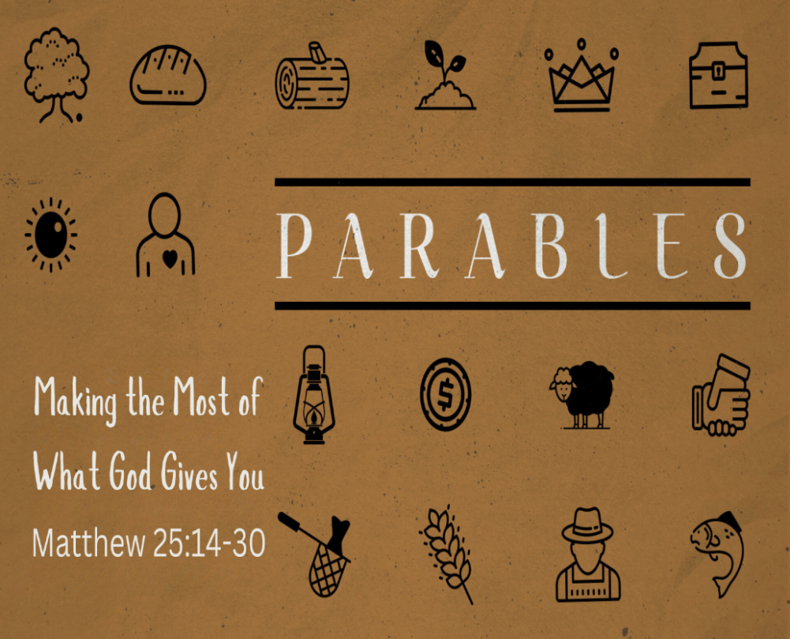

6550 Silas Creek Parkway
Winston-Salem, NC 27106

336-768-5629

www.fairviewmoravianchurch.org

Watchword for 2025

The Lord went in front of them in a pillar of cloud by day,
to lead them along the way, and in a pillar of fire
by night, to give them light.

Exodus 13: 21

