Nineteenth Sunday After Pentecost
October 19, 2025, 10:00 AM

Watchword for the Week:
Proclaim the message; be persistent whether the time is favorable or unfavorable; convince, rebuke, and encourage, with the utmost patience in teaching.
2 Timothy 4: 2

♥Prelude

Tolling the Hour-10:00a.m.

Hymn 714 Blessed Assurance

Welcome and Announcements Bill Shields

Liturgy: Peace and Justice, page 148 Marshall Mathers

Giving of Tithes and Offerings to the Lord
Prayer of Dedication
Anthem There Is Power in the Blood Mary McDonald
Monarch Music 2001 Lorenz Publishing Company CCLI License #751334

Doxology Praise God from Whom All Blessings Flow OLD 100TH

Praise God from whom all blessings flow;
Praise him, all creatures here below;
Praise him above, ye heavenly host;
Praise Father, Son, and Holy Ghost. Amen.

Prayers of the People/Pastoral Prayer

Reading of God’s Word Melissa Thompson
Psalm 121
2 Timothy 3: 14 - 4:5

Sermon Bill Shields
Transformation, Testimony, and Temple
Romans 12: 1-2

Hymn 645 A Charge to Keep I Have

Benediction

Postlude

Sunday School classes follow worship each Sunday.
♥Please sign the Friendship Register at the end of your row and pass it down. If you would like information about our activities or becoming a member of Fairview, please indicate your wish in the appropriate space. Children three years old and under may go to the Nursery.


Thank you to Mr. Bill Shields for being our guest speaker this morning!

Click the QR Code for online giving!

Sunday’s Worship Attendance:
Pledges/Offerings/Gifts/Other for October 12 $ 4,158.00
Monthly Budget Needs $ 35,544.75
Monies Received Month to Date 5,677.00
Needed as of October 12 $ 29,867.75

Reminders:
Lunch and Bible Study – Wednesday, October 22nd at Noon (FH)
Choir Rehearsal - Wednesday’s at 5:30p.m. (S)
Prayer Meeting – Every Tuesday at 9:30a.m. (C)
Women’s Bible Study – Every Tuesday at 11:00a.m. (Lot 63)
Prayer Shawl Group – 2nd Monday of every month at 10:00a.m. (P)
Men’s Bible Study – Every Thursday at 8:00a.m. (Mama Zoes)
WF Food Drive – 2nd Saturday of every month from 11:00a.m. to Noon
We encourage you to bring your donations to the church whenever it is convenient.
Clothes Closet Open - First Saturday of each month at 8:00a.m.
WF Circle Meetings:
WF#1- First Wednesday at 10:00a.m., WF#2- First Wednesday at 10:30a.m., WF#3- Third Tuesday at 5:30p.m., WF#4- First Tuesday at 10:30a.m
Band Rehearsals – Sunday, October 26th and November 2nd at 4:30p.m. (FH)

The November Newsletter Deadline is tomorrow, Monday, October 20th.
If your submission is not received by the monthly cutoff date, we will regretfully be unable to publish it in the current newsletter.

We need your “Trunks” and “candy donations” for our Trunk or Treat event on Saturday, October 25th from 4:00-5:30p.m. Come out and have a wonderful time seeing all of those smiling faces in costumes getting treats!!


The Speas Ministry Breakfast Fundraiser is today immediately following our worship and Sunday School hour. If you cannot make it but would like to donate to this ministry, please send your offering to the church office and designate it to “Speas Ministry.” Thank you!

Fairview Moravian Church

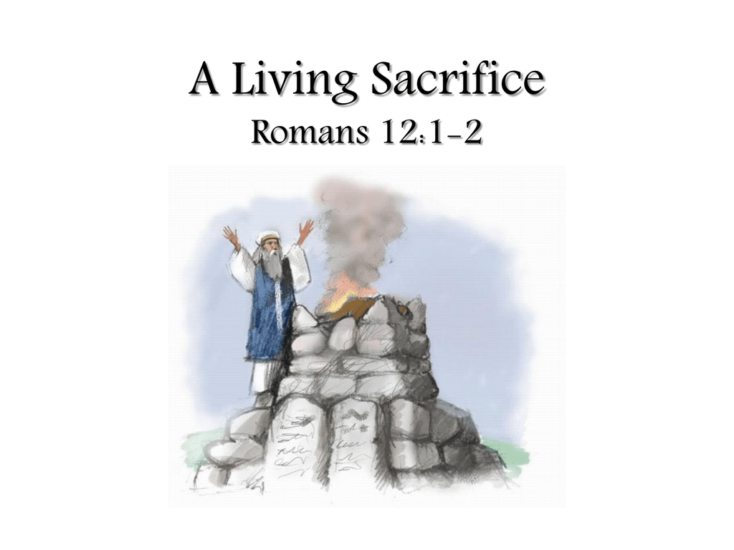

6550 Silas Creek Parkway
Winston-Salem, NC 27106

336-768-5629

www.fairviewmoravianchurch.org

Watchword for 2025

The Lord went in front of them in a pillar of cloud by day,
to lead them along the way, and in a pillar of fire
by night, to give them light.

Exodus 13: 21

