Welcome to Fairview Moravian Church Fourth Sunday after Epiphany
February 1, 2026
Please take a moment to sign the friendship pad in your pew.
Watchword for the week: The Lord is my light and my salvation; whom shall I fear? The Lord is the stronghold of my life; of whom shall I be afraid. Psalm 27: 1

Prelude Martha Evans

Tolling of the Bell
Welcome and Announcements Bill Shields

Hymn 719 Be Thou My Vision

Liturgy: Adoration, page 18 Bill Shields

Giving of Tithes and Offerings to the Lord Dick Joyce
Prayer of Dedication
Anthem He Is Lord of All
Paul Williams/Benjamin Harlan - Shawnee Press 1995
CCLI License #751334

Doxology Praise God from Whom All Blessings Flow OLD 100TH
Praise God from whom all blessings flow;
Praise him, all creatures here below;
Praise him above, ye heavenly host;
Praise Father, Son, and Holy Ghost. Amen!

Reading of God’s Word Dick Joyce
Matthew 5: 3-12 (page 785)

Prayers of the People/Pastoral Prayer Dick Joyce

Sermon Rev. Dr. Michael Brown
“The Beatitudes”

Hymn 635 We Are Called to Be God’s People

Benediction

Postlude Martha Evans

2026 Congregational Watchword
The precepts of the Lord are right, giving joy to the heart.
The commands of the Lord are radiant,
giving light to the eyes.
Psalm 19: 8

♥Please sign the Friendship Register at the end of your row and pass it down. If you would like information about our activities or becoming a member of Fairview, please indicate your wish in the appropriate space.
Children three years old and under may go to the Nursery.

Fairview warmly welcomes Rev. Dr. Michael Brown as our guest speaker this morning. Dr. Brown is a speaker, writer, adjunct professor, and pastor. For a decade, he was successor to Dr. Norman Vincent Peale (author of The Power of Positive Thinking) and Dr. Arthur Caliandro (author of Make Your Life Count) as Senior Minister at Marble Collegiate Church on 5th Avenue in New York City. Prior to serving in NYC, Dr. Brown, an ordained United Methodist clergy, was the Pastor of such churches as Boone United Methodist, Central United Methodist (Asheville), and Centenary United Methodist (Winston-Salem), all in North Carolina. He also preaches each Sunday June-September at Blowing Rock Methodist (a seasonal Worship Chapel for tourists and summer residents in Blowing Rock, North Carolina) and travels nationally, October-May, preaching, lecturing, and speaking for churches, colleges and universities, seminaries, and corporate and civic organizations. He currently teaches Biblical Studies at High Point University (where he also serves as a Trustee) and leads an annual Preaching Cohort for clergy through Duke University Divinity School (in its sixth year). Additionally, he teaches Preaching for the Board of Higher Education and Ministry of The United Methodist Church (via the Course of Study for clergy in the licensing process).


Church Staff

Rev. Dr. Steve Martin, Interim Pastor Patricia Rau, Administrative Assistant
Beth Passmore, Vice Chair of Elders Melissa Thompson, Chair of Trustees
Van Krause, Band/Choir Director Martha Evans, Organist
Bill Wright, Facilities Manager

Our Church Family Prayer List: William Angel, Michael Boerg, Judy Byerly, Shirley Byerly, Nancy Davis, Anna Frances and Alden Dull, Corky Flowers, Phyllis and Riff Footland, Ruth Freeman, Rev. Don Griffin, John Harrold, Jean and Harvey Lunsford, Carolyn and Ken Neal, Penny Ratermann, Sandy Smith, Linda Tuttle, Cleo Willard-Weems.
Friends and Family Prayer List: Barbara Black (mother of Teresa Krause), Tiffany Dodson (mother of Teresa Krause), the Family of Scott Draughn (friends of Pam Tatum), the Family of Steve Hicks (friends of Pam Tatum), Susie Marion (friend of Pam Tatum).
Our Military Prayer List: Jordan Hailey (Navy – son of Jerry Hailey), Daniel Millikan (Army – son of Dianne & Alan Millikan), Jeremiah Millikan (Navy – son of Dianne & Alan), Christian Nixon (National Guard – nephew of Candice & Rod Back), Eric Tise (grandson of Lindsay Tise).

Calendar Reminders:
Prayer Shawl Group – 2nd Monday of every month at 10:00a.m. (P)
Women’s Bible Study – Every Tuesday at 10:45a.m. (CR)
Music & Worship Comm. Meeting – Monday, February 2nd at 5:30p.m. (CR)
Wednesday Lunch and Bible Study – February 4th at Noon (FH)
Choir Rehearsal - Wednesday’s at 5:30p.m. (S)
Men’s Bible Study – Every Thursday at 8:00a.m. (Mama Zoes)
Clothes Closet Open - First Saturday of each month at 8:00a.m.
WF Food Drive – 2nd Saturday of every month from 11:00a.m. to Noon
We encourage you to bring your donations to the church whenever it is convenient.
WF Circle Meetings:
WF#1- First Wednesday at 10:00a.m., WF#2- First Wednesday at 10:30a.m., WF#3- Third Tuesday at 5:30p.m., WF#4- First Tuesday at 10:30a.m.

Attention Committee Chairs and Treasurers – it’s time to get your 2025 Reports for Church Council turned in to the church office no later than Thursday, February 5th. Reporting Church Council is Sunday, February 15th at 11:15a.m.

Fairview Moravian Church
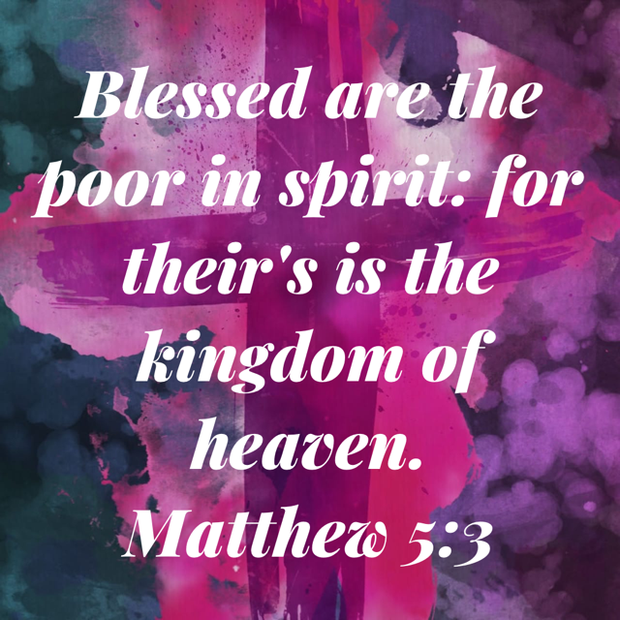

Fairview Moravian Church
6550 Silas Creek Parkway
Winston-Salem, NC 27106

336-768-5629

www.fairviewmoravianchurch.org

