Welcome to Fairview Moravian Church First Sunday after Epiphany
January 11, 2026
Please take a moment to sign the friendship pad in your pew.
Watchword for the week: A bruised reed he will not break, and a dimly burning wick he will not quench; he will faithfully bring forth justice. Isaiah 42: 3

Prelude Martha Evans

Tolling of the Bell
Welcome and Announcements Bill Shields

Hymn 324 Jesus’ Name, Jesus’ Name

Liturgy: New Year, page 143 Betsy Fowler

Giving of Tithes and Offerings to the Lord Barry Self
Prayer of Dedication
Anthem Carol of the Angels
Fairview Chancel Choir, Martha Evans and Van Krause
Evelyn R. Larter and Brad Nix
Lorenz Music 2012 CCLI License #751334

Doxology Praise God from Whom All Blessings Flow OLD 100TH
Praise God from whom all blessings flow;
Praise him, all creatures here below;
Praise him above, ye heavenly host;
Praise Father, Son, and Holy Ghost. Amen!

Reading of God’s Word Barry Self
Isaiah 42: 1-9 (page 584)
Psalm 29 (page 438)
Acts 10: 34-43 (page 895)

Prayers of the People/Pastoral Prayer Bill Shields

Sermon Chaplain R. Jeff Carter
Entering the Year in the Power of the Spirit
Matthew 3: 11-17

Hymn 457 Immortal, Invisible

Benediction Chaplain Carter

Postlude

2026 Congregational Watchword
The precepts of the Lord are right, giving joy to the heart.
The commands of the Lord are radiant,
giving light to the eyes.
Psalm 19: 8

♥Please sign the Friendship Register at the end of your row and pass it down. If you would like information about our activities or becoming a member of Fairview, please indicate your wish in the appropriate space.
Children three years old and under may go to the Nursery.

Fairview welcomes Chaplain R. Jeff Carter to our pulpit this morning.
Chaplain Jeff grew up in Charlotte and attended Little Church on the Lane where he was baptized in the faith in the Summer of 1983. While attending college at UNC-Greensboro, God called him into the ministry. In 1997 Jeff graduated from Regent University’s School of Divinity and has pastored Immanuel Moravian, Hopewell Moravian, Macedonia Moravian and Little Church on the Lane. In January of 2019, Jeff began his ministry as a chaplain with Forsyth Jail and Prison Ministries replacing the long tenure of Rev. Robert Wolfe. He and his wife Tracy have been married for 33 years and have one daughter, Sarah, who is a nurse in Mt. Pleasant, SC and will begin Nurse Practitioner school in the Spring.

Our Church Family Prayer List: William Angel, Michael Boerg, Judy Byerly, Shirley Byerly, Nancy Davis, Anna Frances and Alden Dull, Corky Flowers, Riff Footland, Ruth Freeman and family, Rev. Don Griffin, John Harrold, Jean and Harvey Lunsford, Penny Ratermann, Sandy Smith, Kathin Tarikas, Cleo Willard-Weems.
Friends and Family Prayer List: Tiffany Dodson (daughter of Jeanne Willard), the Family of Scott Draughn (friends of Pam Tatum), the Family of Steve Hicks (friends of Pam Tatum).
Our Military Prayer List: Jordan Hailey (Navy – son of Jerry Hailey), Daniel Millikan (Army – son of Dianne & Alan Millikan), Jeremiah Millikan (Navy – son of Dianne & Alan), Christian Nixon (National Guard – nephew of Candice & Rod Back), Eric Tise (grandson of Lindsay Tise).

Calendar Reminders:
Prayer Shawl Group – 2nd Monday of every month at 10:00a.m. (P)
Women’s Bible Study – Every Tuesday at 11:00a.m. (CR)
Wednesday Lunch and Bible Study – January 21st at Noon (FH)
(upcoming dates: February 4th and February 11th)
Music & Worship Comm. Meeting – Monday, January 26th at 5:30p.m. (CR)
Choir Rehearsal - Wednesday’s at 5:30p.m. (S)
Men’s Bible Study – Every Thursday at 8:00a.m. (Mama Zoes)
Clothes Closet Open - First Saturday of each month at 8:00a.m.
WF Food Drive – 2nd Saturday of every month from 11:00a.m. to Noon
We encourage you to bring your donations to the church whenever it is convenient.
WF Circle Meetings:
WF#1- First Wednesday at 10:00a.m., WF#2- First Wednesday at 10:30a.m., WF#3- Third Tuesday at 5:30p.m., WF#4- First Tuesday at 10:30a.m.

At the end of the worship service on January 18, 2026, there will be an Eagle Scout Ceremony honoring the achievement of Kathin Tarikas as Eagle Scout. The Rev. Scott Venable will participate. We will also have a potluck lunch in the Fellowship Hall following the service (no Sunday School) honoring Kathin. Please bring a side dish to share (chicken and dessert will be provided). Come and celebrate this significant milestone in Kathin's life!

The 2026 Fairview Church Directory will be published in this month. If you have new contact information, please call Patricia at 336-768-5629 or email patricia@fairviewmoravianchurch.org this week to let her know. Thanks!

Need a mid-week spiritual boost? Join us on Wednesday, January 21, 2026, at Noon for our Wednesday Lunch and Bible Study.
Br. Bill Shields will lead our discussion, offering his unique perspective and passion for the scriptures. Whether you are a lifelong student of the Word or simply curious, you are welcome here.
This is an open-door event—bring a friend, neighbor, or family member to share in the delicious meal, fellowship, and inspiration. We look forward to growing in faith together!

We have several flower openings in the coming months. Please call Cynthia Faircloth if you would like to place flowers in the sanctuary on Sunday mornings in honor or memory of a loved one.

Fairview Moravian Church

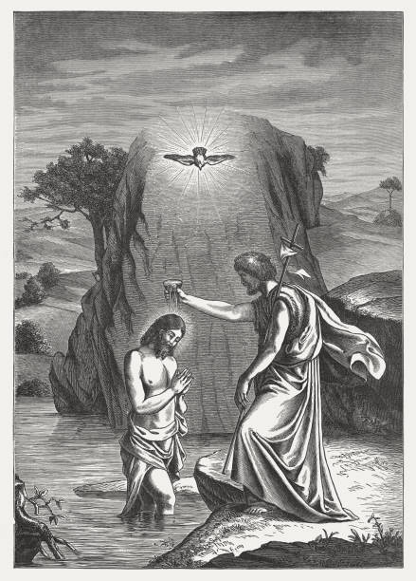

Fairview Moravian Church
6550 Silas Creek Parkway
Winston-Salem, NC 27106

336-768-5629

www.fairviewmoravianchurch.org

