Fairview Moravian Church

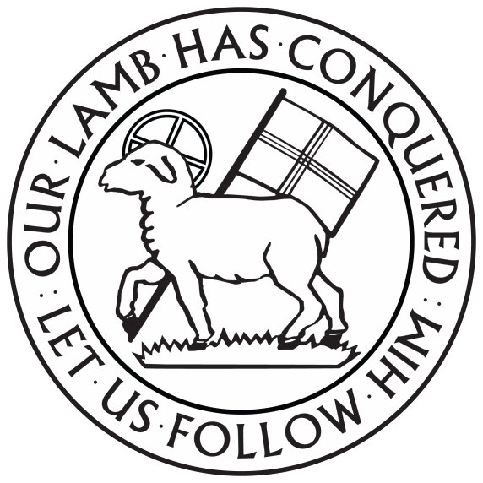

6550 Silas Creek Parkway
Winston-Salem, NC 27106

336-768-5629

www.fairviewmoravianchurch.org

Watchword for 2022

They rise in the darkness as a light for the upright;
they are gracious, merciful, and righteous.
Psalm 112:4

The Chief Elder Festival
November 13, 2022, 10:00 AM

Watchword for the Week:
Brothers and sisters, do not be weary in doing what is right.
2 Thessalonians 3: 13

Prelude

Call to Worship: Hymn 593 How Great the Bliss to Be a Sheep of Jesus

Welcome and Announcements Pastor Tony Hayworth

Moravian Birthday Hymn, insert

Prayers of the People/Pastoral Prayer

Liturgy: Receiving New Members, page 170

Giving of Tithes and Offerings to the Lord
Prayer of Dedication
Anthem Just As I Am Mauldin

Just as I am without one plea but that thy blood was shed for me, and that thou bidst me come to thee, I Lamb of God, I come, I come. Just as I am and waiting not to rid my soul of one dark blot. To thee whose blood can cleanse each spot, O Lamb of God, I come, I come. I come broken to be mended. I come wounded to be healed. I come desperate to be rescued. I come empty to be filled. I come guilty to be pardoned by the blood of Christ, the Lamb. And I’m welcomed with open arms, praise God, just as I am. Just as I am I would be lost, but mercy and grace my freedom bought. And now to glory in your cross, O Lamb of God I come, I come. I come broken to be mended, I come wounded to be healed. I come desperate to be rescued. I come empty to be filled. I come guilty to be pardoned by the blood of Christ, the Lamb. And I’m welcomed with open arms, praise God, just as I am. I come broken to be mended. I come wounded to be healed. I come desperate to be rescued. I come empty to be filled. I come guilty to be pardoned by the blood of Christ, the Lamb. And I’m welcomed with open arms, praise God, just as I am. Praise God, just as I am. Just as I am.

“Just As I Am (I Come Broken)”
Arranged by Russell Mauldin,
2012 CCTB Music (ASCAP)/Brentwood Benson a division of Capital Publishing
CCLI License #751334

Doxology Praise God from Whom All Blessings Flow OLD 100TH

Praise God from whom all blessings flow;
Praise him, all creatures here below;
Praise him above, ye heavenly host;
Praise Father, Son, and Holy Ghost. Amen!

Meditation Living in a Gated Community Pastor Tony
John 10: 1-10

Hymn 673 Christian Hearts, in Love United

Service of Holy Communion, Blue Booklet Page 3
In Celebration of the Chief Eldership of Jesus Christ

Benediction

Postlude

Sunday School classes follow worship each Sunday.

♥Please sign the Friendship Register at the end of your row and pass it down. If you would like information about our activities or becoming a member of Fairview, please indicate your wish in the appropriate space.

Children three years old and under may go to the Nursery.

The flowers today are given to the Glory of God by the Women’s Fellowship.

We are excited this morning to receive new members into the Fairview Congregation. Joining us are Beth Passmore and Trudy Smith. Please warmly welcome these newest members of the Fairview Church Family!!

The Blum Chapel has received a gift in memory of Lillie Mae Joyce from Mollie and Robert Rascoe.
The Maggie Styers Missionary Chapter has received a gift in memory of Anne Collins and C.L. Hyatt from Carolyn and Ken Neal.
The Outreach Fund has received gifts in memory of Anne Collins and Bill Davis from Gwen and Bill Shields.
Sunday’s Worship Attendance: 62
Pledges/Offerings/Gifts/Other for November 6 $3,547.00
Month Budget Needs $36,104.25
Monies Received Month to Date 3,547.00
Needed as of November $32,557.25

Reminders:
Candle Trim – Monday. November 14 at 10a.m.
Prayer Shawl Group, Monday, November 14 at 10a.m.-P
Jt. Bd. Meeting – Monday, November 14 at 5:30p.m.-FH
Outreach Committee Mtg. – Thursday, November 17 at 11a.m.-CR
Church Council – November 20, after Worship-S

PRAYER CONCERNS THIS WEEK

Our Church Family:

Doris Brame, Judy Byerly, Collins Family, Ann Carroll, Bob Dalton, Corky and Danny Flowers, Riff Footland, Sondra Goforth, Anne Griffin, John Harrold, Dorcas and Ken Hauser, Peggy Hoyle, Jolleen Johnson, Jean and Harvey Lunsford, Nancy Manuel, Lucy Millikan, Brenda Miller, Tom Nicholson, Doris “DG” Noell, Joanna and Bill Oehman, Harry Sapp, Larry Sprinkle, Pam Tatum, Lindsay Tise, Nancy and Ken Tomberlin, Diane Wright.

Our Family and Friends:

Thelma Fulp (Sheri Fulp’s mother), Tina Markanda (friend of Candice and Rod Back), Mary Kolischak (friend of Candice and Rod Back), Drew Mayse (friend of Pam Tatum), Larry McRacken (friend of Susan and Gary Hope), Gayle Pfaff (family of Bobby Bennett), Cele Shaver (cousin of Pam Tatum), Chip Van (friend of Pam Tatum).

Pray for our Friends and Family in the Military:

Jordan Hailey (Navy – son of Jerry Hailey), Daniel Millikan (Army – son of Dianne & Alan Millikan), Jeremiah Millikan (Navy – son of Dianne & Alan), Christian Nixon (National Guard – nephew of Candice & Rod Back,
Eric Tise (Air Force– grandson of Lindsay Tise).

Fairview’s Annual Church Council will convene in the sanctuary on Sunday, November 20, following the 10:00a.m. worship service. All communicant members of the congregation are encouraged to attend and participate. The Nominating Committee members, Cynthia Faircloth-Chair, Shirley Byerly, Dianne Millikan and Mollie Rascoe present the following slate: Elders (we will elect two): Melinda Yarbrough and Marshall Mathers. Trustees (we will elect two): Melissa Thompson and Doris Bostian. Central Trustee: Barry Self. Central Elder: Jerry Hailey. Nominations can be made from the floor (be sure the nominee has approved his/her name for nomination). Respectfully, the Nominating Committee.

“Moravian Birthday Hymn”

With your presence, Lord, our Head and Savior,
bless them now, we humbly pray;
our dear heavenly Father’s love and favor
be their comfort every day.
May God’s Spirit now in each proceeding
favor them with his most gracious leading;
thus shall they be truly blessed,
both in labor and in rest.

Happy Birthday!!

11/1 Phil Stith
11/3 Linda Tuttle
11/4 Peggy Hoyle
11/4 Sam Hauser
11/7 Joanna Oehman
11/10 Eddie Hubbard
11/11 Betty Johnson
11/13 Bob Sparrow
11/18 Aubrey Brendle
11/24 Mary Beard
11/26 Lou Sikora
11/26 Richard Yarbrough
11/29 Johanna Reich

We will trim candles for our Christmas Lovefeast services on Monday, November 14th at 10:00a.m. in the Fellowship Hall.

Fairview Fare
Saturday, November 19, 2022, 8:00am to Noon

Baked goods, Cakes, Pies, and of course Chicken Pies. Country Store-candles, jams, jellies, canned goods, fresh vegetables and more. Breakfast and Lunch will be available to Purchase.

This holiday season, we are once again decorating our sanctuary with poinsettias. If you would like to purchase a poinsettia in honor or in memory of a loved one, please fill out the form below and return it to the Church Office with a check made payable to Fairview Moravian Church. The cost of each poinsettia is $8.00 and payment must be made when the order is placed. Sunday, November 22nd is the deadline to place your orders. The poinsettias will go in the Sanctuary on December 18th and may be picked up only after the 5:00 p.m. Christmas Eve Candlelight Lovefeast.

Name
(Please Print)

Number of poinsettias (_____________) x $8.00 each

In honor of

In honor of

In memory of

In memory of

Ladies Christmas Luncheon

All ladies of the church are invited to a Christmas Luncheon in the fellowship hall on Wednesday, December 7th at Noon. The meal is being prepared by the Women’s Fellowship Executive Board and the cost is $6.00 per person.

Everyone is invited to be involved in each of the ministry areas of the congregation. If you have questions about becoming a participant in our music ministry, children’s ministry, Sunday School, outreach projects or mission efforts, please speak to an usher.

