Fairview Moravian Church

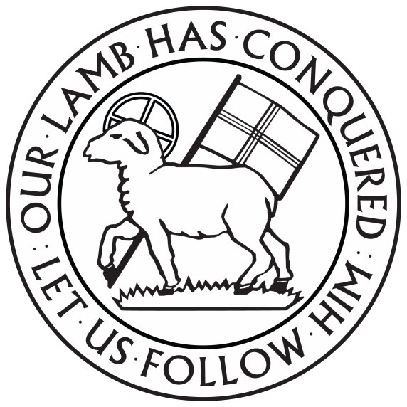

6550 Silas Creek Parkway
Winston-Salem, NC 27106

336-768-5629

www.fairviewmoravianchurch.org

Watchword for 2022

They rise in the darkness as a light for the upright;
they are gracious, merciful, and righteous.
Psalm 112:4

Eighteenth Sunday after Pentecost
October 9, 2022, 10:00 AM

Watchword for the Week:
Proclaim the message; be persistent whether the time is favorable or unfavorable; convince, rebuke, and encourage, with the utmost
patience in teaching.
2 Timothy 4: 2

Prelude

Call to Worship: Hymn 792 I Serve a Risen Savior

Welcome and Announcements or Tony Hayworth

Stewardship Witness Jerry Hailey

Prayers of the People/Pastoral Prayer

Liturgy: Evangelism, p. 133 Dick Joyce

Giving of Tithes and Offerings to the Lord
Prayer of Dedication
Anthem A Holy Sacrifice Choplin
Commissioned in honor of Lewis Phillips at First Baptist Church

O Lord who are we to stand before You? Who are we to come before Your mighty throne? For Lord, You are so perfect and so holy, we could never come in our strength alone. As we come to worship You as You call Your church to do, we bring to You our humble gifts of praise. If we offer You our best, we know that You will bless and make our gifts a holy sacrifice.

May the offering of our lives be a holy sacrifice to You. Wash them clean, make them true, let them be a holy sacrifice to You.

If we could spend our earthly days singing lofty songs of praise, yet no music would be worthy of Your throne. But if our gifts are from the heart, then Your spirit does its part to make them a holy sacrifice.

By Pepper Choplin
Copyright 2000 by Glorysound, Inc. A Division of Shawnee Press, Inc.
CCLI License #751334

Doxology Praise God from Whom All Blessings Flow OLD 100TH

Praise God from whom all blessings flow;
Praise him, all creatures here below;
Praise him above, ye heavenly host;
Praise Father, Son, and Holy Ghost. Amen!

Children’s Message Kathy Davis

Reading of God’s Word Bill Shields Psalm 121
Luke 18: 1-8

Sermon To Be Continued Pastor Tony
2 Timothy 3: 14-4:5

Hymn 630 Good News! Our Christ Has Come!

Benediction

Postlude

Sunday School classes follow worship each Sunday.

♥Please sign the Friendship Register at the end of your row and pass it down. If you would like information about our activities or becoming a member of Fairview, please indicate your wish in the appropriate space.

Children three years old and under may go to the Nursery.

The flowers in the sanctuary today are given to the Glory of God and in loving memory of my son, Craig by Penny Ratermann.

The Landscaping Fund has received gifts in memory of Lillie Mae Joyce from Mary and Hoyt Beard, Doris Bostian, Pat and Harry Sapp and the Women’s Fellowship.
The Outreach Fund has received a gift in memory of Marjorie Humbert, Bill Davis and Lillie Mae Joyce from Judy and Jerry Byerly.
Sunday’s Worship Attendance: 54
Pledges/Offerings/Gifts/Other for October 9 $3,765.00
Month Budget Needs $36,104.25
Monies Received Month to Date 6,053.00
Needed as of October 9 $30,046.25

Reminders:
WF Circle 3 Meeting – Monday, October 17 at 3pm.-FH
Bible Study – Tuesday, October 18 at 6:30pm.-FH
Bible Study and Lunch-CT # 5 – Wednesday, October 19 at Noon
Outreach Committee Meeting – Thursday, October 20 at 11am-CR
WF Executive Bd. Mtg. – Monday, October 24 at 10:30am-CR
*Special Called Church Council – November 6th after worship
Church Council – November 20th after worship

PRAYER CONCERNS THIS WEEK

Our Church Family:

Mary Beard, Doris Brame, Judy Byerly, Anne Collins, Ann Carroll, Bob Dalton, Corky and Danny Flowers, Riff Footland, Rev. Don Griffin, John Harrold, Jane Hilker, Peggy Hoyle, Jolleen Johnson, Lillie Mae Joyce family, Jean and Harvey Lunsford, Nancy Manuel, Lucy Millikan, Brenda Miller, Tom Nicholson, Doris “DG” Noell, Joanna and Bill Oehman, Harry Sapp, Larry Sprinkle, Frankie Stith, Lindsay Tise, Nancy and Ken Tomberlin, Diane Wright.

Our Family and Friends:

Fred McKinney (brother of Linda Mathers), Debbie Stone (friend of Brittany Hawks).

Pray for our Friends and Family in the Military:

Jordan Hailey (Navy – son of Jerry Hailey), Daniel Millikan (Army – son of Dianne & Alan Millikan), Jeremiah Millikan (Navy – son of Dianne & Alan), Christian Nixon (National Guard – nephew of Candice & Rod Back,
Eric Tise (Air Force– grandson of Lindsay Tise).

Fairview Friends…reorganizational meeting. Please plan to gather in the Fellowship Hall for a Baked Potato Bar Luncheon on October 27th at noon. After lunch we will have an activity and discuss future gatherings, programs, and events.

The Prayer Shawl Ministry meets the 2nd Monday of every month at 10:00am in the Parlor. Questions? Please email: jaschorer@yahoo.com

Next Sunday, October 23, is Mission Sunday. Our guest speaker will be Lou Carrico, Executive Director of the Winston Salem Rescue Mission.

At our November 20th Church Council will hold elections for the following: 2 for the Board of Elders, 2 for the Board of Trustees, and one each for the Salem Congregation Central Trustee and Elder. With prayerful consideration please submit your suggestions for consideration by the Nominating Committee. The Nominating Committee members are: Cynthia Faircloth (Chair), Bill Shields, Shirley Byerly, Kathy Davis, Mollie Rascoe, and Dianne Millikan.

Everyone is invited to be involved in each of the ministry areas of the congregation. If you have questions about becoming a participant in our music ministry, children’s ministry, Sunday School, outreach projects or mission efforts, please speak to an usher.

