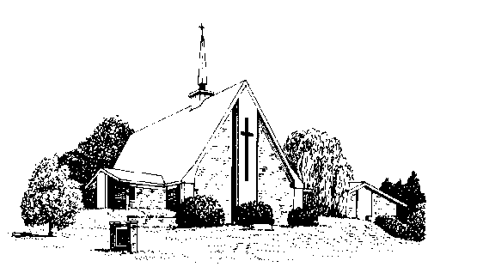
Pray without ceasing.
1 Thessalonians 5:17

Fairview Moravian Church

May 2020

Joint Board News

A Prayer During the Pandemic

Jesus Christ, healer of all, stay by our side in this time of uncertainty and sorrow.
Be with those who have died from the virus. May they be at rest with you in your eternal peace.
Be with the families of those who are sick or have died. As they worry and grieve, defend them from illness and despair. May they know your peace.
Be with the doctors, nurses, researchers and all medical professionals who seek to heal and help those affected and who put themselves at risk in the process. May they know your protection and peace.
Be with the leaders of all nations. Give them the foresight to act with charity and true concern for the well-being of the people they are meant to serve. Give them the wisdom to invest in long-term solutions that will help prepare for or prevent future outbreaks. May they know your peace, as they work together to achieve it on earth.
Whether we are home or abroad, surrounded by many people suffering from this illness or only a few, Jesus Christ, stay with us as we endure and mourn, persist and prepare. In place of our anxiety, give us your peace.
Jesus Christ, heal us. Amen.

FROM YOUR JOINT BOARDS

Our boards decided to suspend in-person gatherings at the church for at least several weeks. This decision was in keeping with stay-at-home orders passed down from the Mayor, the Governor, and the President. Gatherings of more than ten have been prohibited. This decision was made with much reluctance by the staff and board members, but is consistent with recommendations from the PEC.
Meanwhile Fairview is indebted, not only to Pastor Jeff, but to our members Jerry Hailey, Rod Back, Bill Wright, Dick Joyce, and perhaps others for our online capabilities which enable us all to attend meetings from remote locations, and to attend online worship and Sunday School as well. Those without computers can do the same with telephones. Many hours of work went into setting all this up. Many thanks to our Minister of Music, Lewis Phillips, Pianist, Nancy Morgan and several of our choir members, readers and many others for coming in to make sure we have beautiful and meaningful worship services on Sunday mornings to enjoy. Thank you to Bill Shields and Jerry Hailey who have brought great messages to us the last couple of Sundays.
Our Pastor Call Process is ongoing, though confidentiality requirements from the PEC do not allow board members to share much information as yet. We are working closely with the PEC and actively considering some strong candidates. As mentioned before, our Moravian call process is cumbersome, slow, and time-consuming. Both pastoral candidates and the church must be given time to consider decisions that will have long-term consequences. We are anxious to share, and will share, what information we can just as soon as we can.
We all do our best to remember that God is in control
in these trying times just as he was before all this came
about. Please continue to pray for Fairview, our congregation, our worship, staff, boards, and officers.

2. Candice Back
4. Wendy Hilker, John Yarbrough
5. Robin Yokley, Will Wright
8. Lewis Phillips, LuAnn Timmons
10. Marie Kiger
16. Ruth Freeman
20. Morgan Fox
21. Melinda Yarbrough
22. Hailey Hubbard
25. Annie Harrold
26. Nancy Tomberlin
27. Harvey Lunsford, Jennings Snyder
28. Edna Teague
29. Robert Rascoe, Aurora Cohoon
30. Alan Millikan

Thank you to everyone that has made all of our online services possible. Thank you to Jerry Hailey and Bill Shields for providing us with outstanding sermons the past two Sundays. As always, the music sounds so beautiful each and every Sunday. Fairview is blessed to have so many talented and giving people.

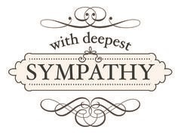The congregation was saddened by the loss of two of our members…
John Snyder on April 10th and Noel Harris on April 20th. Please keep their families in your thoughts and prayers.

Remembering Our Members In Prayer…
Roger Carmichael; Oneita Dease; Ruth and Everett Freeman; John Harrold; Nancy Manuel; Sharlene Medley; Dot Moore; Bob and Earlette Peek; Harry Sapp; Brooks Snyder; Nancy and Ken Tomberlin.

Shut In:
Nelson Cannon; Sam Hardister; Gayle Heck; Jolleen Johnson; Nancy Manual; Ann and David Marcus; Lucy Millikan; Ruby Pulliam.

Nursing Home:
Jill Mayer, Betty Beeson, Al Butner, Tootie Barbour, Opal Miller, Doris Noell, Barbara Giesler, Eleanor Swaim, Lillie Mae Joyce, Edna Teague, Betty Bennet, George Brannock.

The Fairview Congregation is very blessed to have people taking care of each other. Due to us not having a Lovefeast at church during Easter, one couple delivered Lovefeast and hot cross buns to 100 people. Neighbors baking for neighbors, buying items for people not able to leave their homes, calling each other is our way of helping during this pandemic. Enjoying being with our family more and not rushing to appointments, taking walks and seeing nature. Hopefully we will have our 90th Birthday Party in June and remember our Fall Fare on November 14th. Stay safe and keep a song in your heart.

“Try to show grace, mercy and compassion, for one day you may need them.”
― Wayne Gerard Trotman

Virtual Worship
Join us on Sundays for worship at 10:00a.m. There are several ways to join us.
Participants = Use our Zoom address https://zoom.us/j/4869198453 / Click “Join Meeting” /Meeting ID: 486 919 8453, then enter password “112233”
If you have used our link before, your computer may not need the Meeting ID or Password. You may also dial in using the information below.
- Dial 1-929-436-2866,
- Meeting ID: 486 919 8453,
- then enter password “112233”
Viewers = Use YouTube Live! https://youtu.be/8JnLUaxPJXo

