Fourth Sunday after Pentecost
June 17, 2018, 10:00 AM

Watchword of the Week:
It is good to give thanks to the Lord, to sing praises
to your name, O Most High.
Psalm 92: 1

♥Prelude God, Give Us Christian Homes Arr. Barry

Welcome and Announcements Rev. Scott Venable

Prayers of the People/Pastoral Prayer Rev. Venable

Call to Worship Open Our Eyes, Lord Arr. Schrader

*Liturgy for Christian Homes, page 119 Rev. Venable
(Following the Liturgy, please greet those around you in the Name of Christ.)

Giving of Tithes and Offerings to the Lord
Prayer of Dedication
Anthem Hymn of Promise Sleeth
In the bulb there is a flower; in the seed, an apple tree; in cocoons, a hidden promise: butterflies will soon be free! In the cold and snow of winter there's a spring that waits to be, unrevealed until its season, something God alone can see.
There's a song in every silence, seeking word and melody; there's a dawn in every darkness, bringing hope to you and me. From the past will come the future; what it holds, a mystery, unrevealed until its season, something God alone can see.
In our end is our beginning; in our time, infinity. In our doubt there is believing; in our life, eternity. In our death, a resurrection; at the last, a victory, unrevealed until its season, something God alone can see.
“Hymn of Promise,”
Words and Music by Natalie Sleeth
©1995 Hope Publishing Company CCLI License #751334

*Doxology

Children’s Message Kathy Cooke
Reading of God’s Word Sandy Smith
Ezekiel 17: 22-24 (page 684, LP page 1308)
2 Corinthians 5: 6-10, 14-17 (page 939, LP page 1798)

* Hymn 449 For the Fruit of All Creation

Sermon Rev. Venable
Hope Sprouting From the Ground
Mark 4: 26-34 (page 815, LP page 1558)

*Hymn of Response # 461 O God, Our Help in Ages Past

There will be an opportunity during the singing of the final hymn to respond to God in a tangible way. Everyone is invited to come to the front of the sanctuary to pray quietly with one of our ministers as the hymn is sung. This could be a time of personal prayer, a first-time commitment to Christ, a renewal of faith, or any other need that God places on our hearts.

*Benediction

*Postlude O God, Our Help in Ages Past Arr. Kerrick

♥Please sign the Friendship Register at the end of your row and pass it down. If you would like information about our activities or becoming a member of Fairview, please indicate your wish in the appropriate space.
Children three years old and under may go to the Nursery.
*Please stand.

The flowers in the sanctuary today are given to the Glory of God and in honor and in memory of all the men of Fairview by the Women’s Fellowship.

Last Sunday Attendance – 110 Sunday School – 47
Pledges/Offerings/Gifts/Other for June 10th – $11,193.16
Monthly Budget Needs $40,636.34
Monies Received Month to Date 18,696.81
Needed as of June 10th $21,939.53

Thanks to the generosity of many members and friends of Fairview, the Sanctuary Renovation Fund and the Carpet Fund have been paid in full. What a wonderful blessing! We would like to encourage members and friends to designate future Memorial Gifts to the General Fund which supports all the important ongoing ministries of our congregation. Thank you.
Stewards of Service This Week:

Ushers: Dick Joyce, Jean Townsend, Sharlene Medley
Maurice Melton
Greeters: Oneita Dease & Amy Mendenhall
Worship Nursery:
Sunday School Nursery: Phyllis Footland
Sound System Operator: Betty Ferguson
Elder of the Month: Terri Barringer/Carolyn Neal
Trustee of the Month: Danny Ferguson

MEMORIALS

The Choir Fund has received a gift in loving memory of Rev. John Giesler from Judy and Jerry Byerly.
The General Fund has received gifts in memory of Gary Wayne Overfelt and T. Glenn Joyce, Jr. for Father’s Day and Glenn’s birthday from Linda Joyce Overfelt and the Dorias of Naples, Fl and in memory of the Rev. John Giesler by Sandy Smith, Janet and Richard Erickson and in honor of Alice Bess’s birthday by Pat and Harry Sapp and in memory of Roslyn and Harry Southerland and Ellen and Bill Flowers by Corky and Danny Flowers.

CALENDAR: JUNE 17 – JUNE 24, 2018

Today 10:00 AM Worship
11:10 AM Sunday School
3:00 PM Consecration Service for Rev. Tom Shelton
at Friedberg Moravian Church
Monday 6:00 PM Back to Basics (AB)
7:00 PM WF Circle # 3 (Parlor)
Tuesday 9:00 AM Activity Building in Use for Private Function
10:00 AM Staff Meeting
Wednesday 7:00 PM Choir Practice (S)
Friday 6:00 PM Back to Basics (AB)
Sunday 10:00 AM Worship
11:10 AM Sunday School

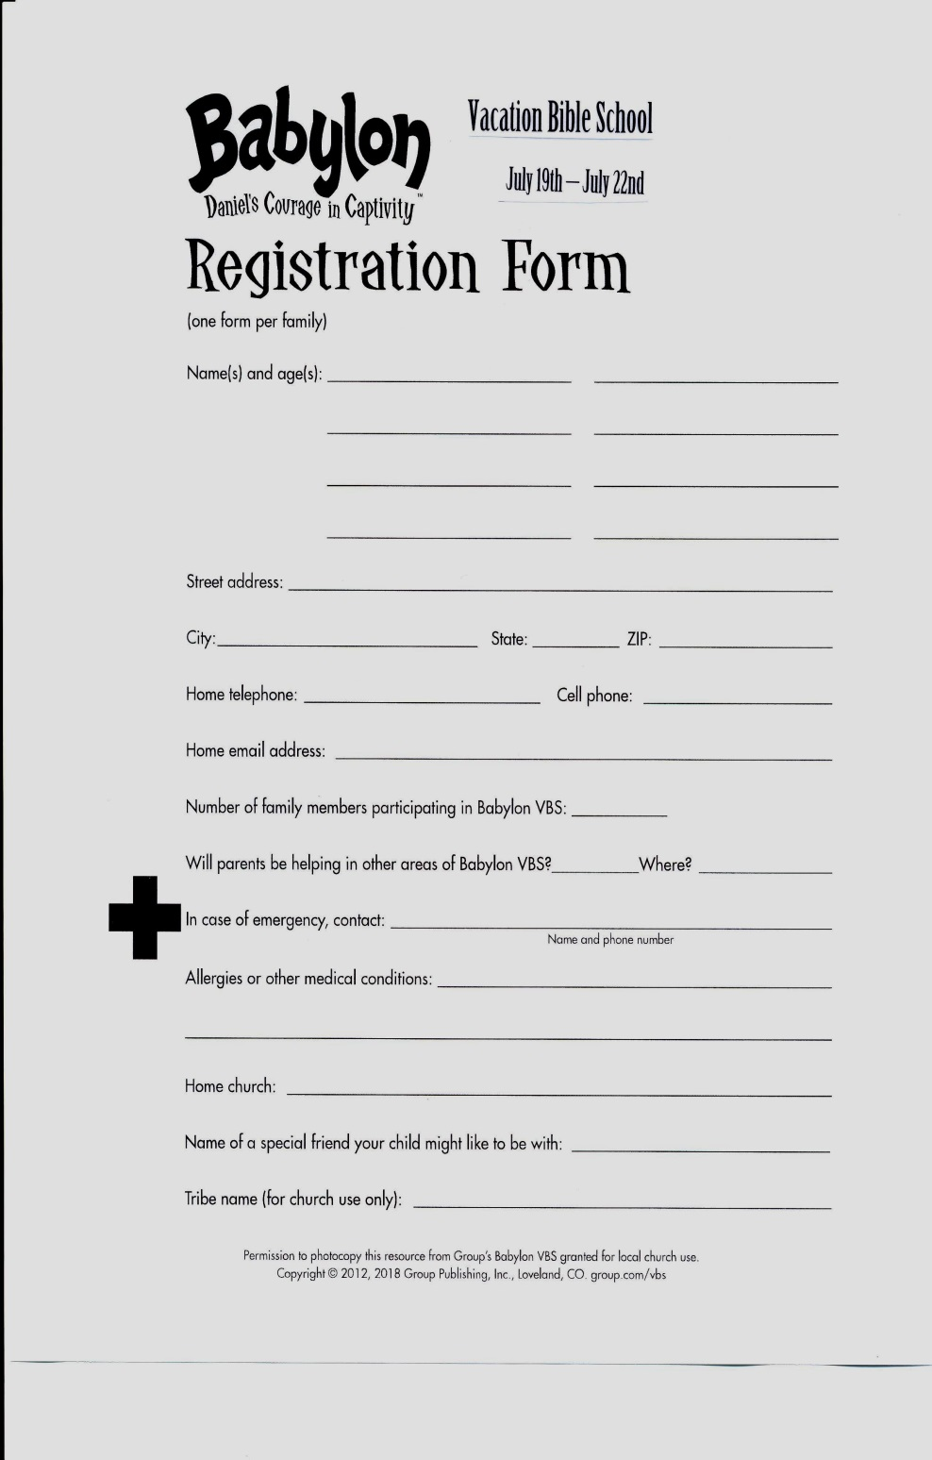
Fairview’s God & Country Celebration
Saturday, June 30th

Games – 4:00 p.m.
Band Concert – 5:00 p.m.
Cookout – 6:00 p.m.

Make plans to come and bring a friend!

2019 Daily Text Order Form

It’s hard to believe, but now is the time to order your 2019 Daily Texts! In order for our members to get the Early Bird discount, you need to place your order no later than Sunday, July 22nd, 2018. Orders will not be accepted after July 22nd, so be sure to order early to get it in. We order only a few extra books; so if you plan to purchase these publications through Fairview, please fill out the order form below and place it in the offering plate or turn in to the Church Office.

Please indicate below how many of each you want to order:

Paperback Daily Texts ($8.93)

Hard Cover Daily Texts ($12.75)

Large Print Daily Texts ($11.05)

2019 Directory & Statistics -- special price of $5.00 if
purchased with your Daily Text

2019 Directory & Statistics – $8.50 if purchased alone

Total Number of Books
Pre-payment is appreciated.

Name

Phone Number

If you order Daily Texts, please be sure you pick them up.

