Third Sunday after Pentecost
June 10, 2018, 10:00 AM

Watchword of the Week:
Lord, hear my voice! Let your ears be attentive to the
voice of my supplications!
Psalm 130: 2

♥Prelude Take My Life and Let It Be Arr. Whitworth

Welcome and Announcements Rev. Scott Venable

Recognition of Fairview Teachers

Prayers of the People/Pastoral Prayer

Call to Worship This Day Is Holy to the Lord WORSHIP

*Liturgy for Education, page 127 Rev. Venable
(Following the Liturgy, please greet those around you in the Name of Christ.)

Giving of Tithes and Offerings to the Lord
Prayer of Dedication
Anthem Grace Alone Arr. Koerts

Ev’ry promise we can make, ev’ry prayer and step of faith, ev’ry diff’rence we will make is only by His grace. Ev’ry mountain we will climb, ev’ry ray of hope we shine, ev’ry blessing left behind is only by His grace.

Grace alone which God supplies, strength unknown He will provide. Christ in us, our Cornerstone; we will go forth in grace alone.
Ev’ry soul we long to reach, ev’ry heart we hope to teach, ev’rywhere we share His peace is only by His grace. Ev’ry loving word we say, ev’ry tear we wipe away, ev’ry sorrow turned to praise is only by His grace.

“Grace Alone’, Words and Music by Scott Wesley Brown
and Jeff Nelson; Arranged by James Koerts
©2013 Universal Music – Brentwood Benson Publishing
CCLI License #751334
*Doxology

Children’s Message Linda Mathers
Reading of God’s Word Doris Bostian
Isaiah 55: 6-11 (page 598, LP page 1148)
Ephesians 4: 11-16 (page 951, LP page 1821)

* Hymn 666 Help Us, O Lord, to Learn

Sermon Rev. Venable
Sowing the Word and Growing Faith
Matthew 13: 1-23 (page 794, LP page 1516)

*Hymn of Response # 610 Take My Life That It May Be

There will be an opportunity during the singing of the final hymn to respond to God in a tangible way. Everyone is invited to come to the front of the sanctuary to pray quietly with one of our ministers as the hymn is sung. This could be a time of personal prayer, a first-time commitment to Christ, a renewal of faith, or any other need that God places on our hearts.

*Benediction

*Postlude Teach Me, O Lord, I Pray Arr. Whitworth

♥Please sign the Friendship Register at the end of your row and pass it down. If you would like information about our activities or becoming a member of Fairview, please indicate your wish in the appropriate space.

Children three years old and under may go to the Nursery.

*Please stand.

The flowers in the sanctuary today are given to the Glory of God and in honor of all the Ushers by Bill Wright.

Last Sunday Attendance – 109 Sunday School – 45
Pledges/Offerings/Gifts/Other for June 3rd – $7,503.65
Amount Owing on Office Carpet – $4,229.21
Monthly Budget Needs $40,636.34
Monies Received Month to Date 7,503.65
Needed as of June 3rd $33,132.69

With the most recent donations that we’ve received to the Sanctuary Renovation Fund, I am pleased to announce that it has been paid off. Thank you so much for your generious donations, thoughtfullness and prayers!

Stewards of Service This Week:

Ushers: Lindsay Tise, Jerry Byerly, David Church,
Ryan Church, Jeanne Willard
Greeters: Terri and David Barringer
Worship Nursery: Kathy Saylor
Sunday School Nursery: Eugenia Ivy
Sound System Operator: Henry Hilker
Trustee of the Month: Danny Ferguson

MEMORIALS

The Sanctuary Renovation Fund has received gifts in honor
of Alice Bess’s birthday by Betty Simmons and in honor of Evelyn West’s 100th birthday by Betty and Danny Ferguson.
The Carpet Fund has received gifts in loving memory of Joe Ratermann by his wife, Penny and in honor of Alice Bess’s birthday by Pat and Harry Sapp.

CALENDAR: JUNE 10 – JUNE 17, 2018

Today 8:00 AM Men’s Breakfast Gathering (FH)
10:00 AM Worship-Teacher Appreciation Sunday
11:00 AM Reception Honoring Our Teachers (P)
11:10 AM Sunday School
3:00 PM Concecration Service for Rev. Carol Foltz
at Trinity Moravian Church
Monday 6:00 PM Back to Basics (AB)
7:00 PM Jt. Board Meeting (P) with Elders (P)
and Trustees (CR) to follow
Tuesday 10:00 AM Staff Meeting
11:00 PM Outreach Committee Meeting (CR)
3:00 PM TAI CHI Exercise Class (FH)
Wednesday 7:00 PM Choir Practice (S)
Friday 6:00 PM Back to Basics (AB)
Sunday 10:00 AM Worship
11:10 AM Sunday School
3:00 PM Concecration Service for Rev. Tom Shelton
at Friedburg Moravian Church

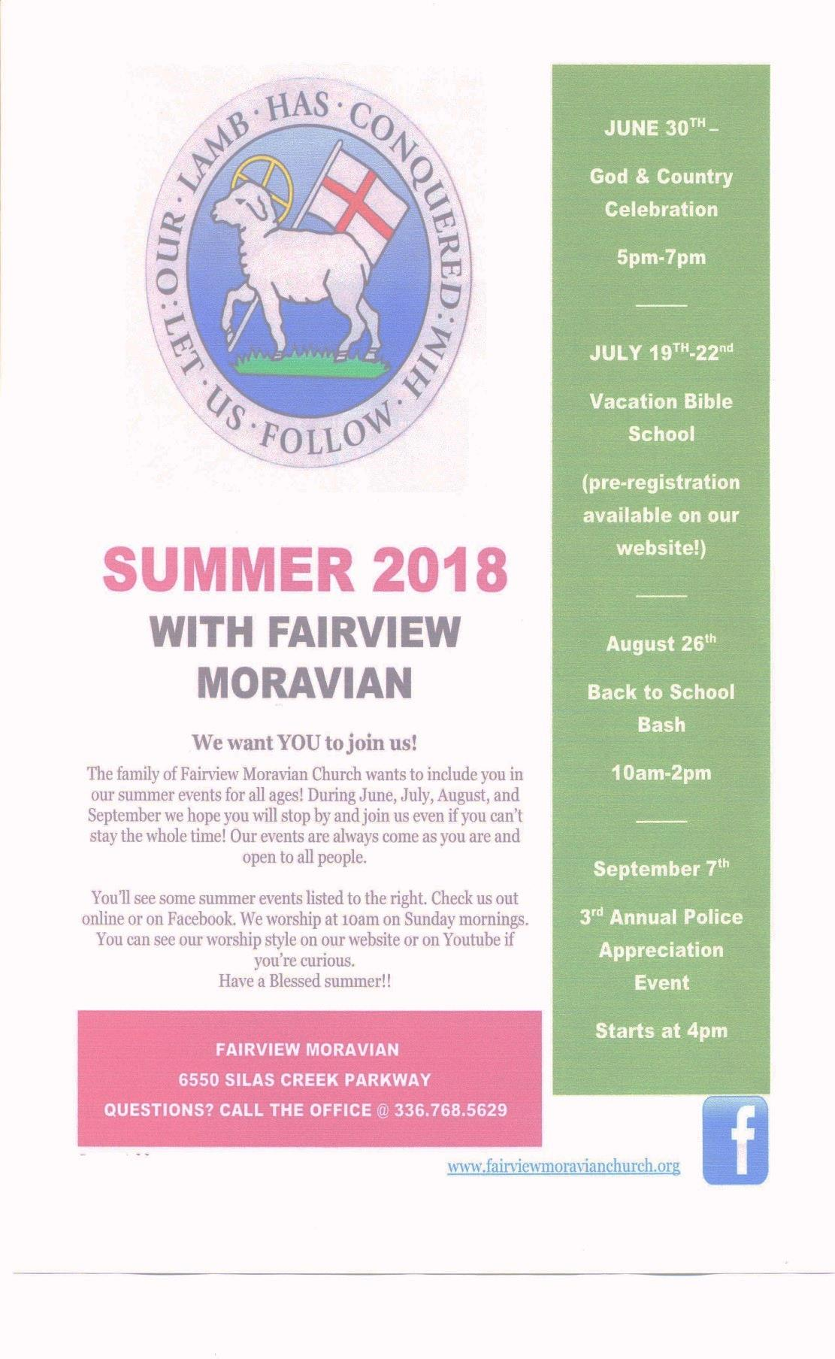
Fairview’s God & Country Celebration
Saturday, June 30th

Games – 4:00 p.m.
Band Concert – 5:00 p.m.
Cookout – 6:00 p.m.

Make plans to come and bring a friend!

2019 Daily Text Order Form

It’s hard to believe, but now is the time to order your 2019 Daily Texts! In order for our members to get the Early Bird discount, you need to place your order no later than Sunday, July 22nd, 2018. Orders will not be accepted after July 22nd, so be sure to order early to get it in. We order only a few extra books; so if you plan to purchase these publications through Fairview, please fill out the order form below and place it in the offering plate or turn in to the Church Office.

Please indicate below how many of each you want to order:

Paperback Daily Texts ($8.93)

Hard Cover Daily Texts ($12.75)

Large Print Daily Texts ($11.05)

2019 Directory & Statistics -- special price of $5.00 if
purchased with your Daily Text

2019 Directory & Statistics – $8.50 if purchased alone

Total Number of Books
Pre-payment is appreciated.

Name

Phone Number

If you order Daily Texts, please be sure you pick them up.

