Fifth Sunday after Pentecost
June 24, 2018, 10:00 AM

Watchword of the Week:
It is good to give thanks to the Lord, to sing praises
to your name, O Most High.
Psalm 92: 1

♥Prelude For the Beauty of the Earth Arr. Kocher

Welcome and Announcements Pat Sapp

Prayers of the People/Pastoral Prayer

Call to Worship Let the Beauty of the Lord Hawkins

*Liturgy for Creation, page 26
(Following the Liturgy, please greet those around you in the Name of Christ.)

Giving of Tithes and Offerings to the Lord
Prayer of Dedication
Anthem His Eye Is on the Sparrow Arr. Hayes

Why should I feel discouraged? Why should the shadows come? Why should my heart be lonely and long for heav’n and home when Jesus is my portion? My constant Friend is He. His eye is on the sparrow, and I know He watches me. His eye is on the sparrow, and I know He watches me.

I sing because I’m happy, I sing because I’m free,
For His eye is on the sparrow, and I know He watches me.

Whenever I am tempted, whenever clouds arise, when songs give place to sighing, when hope within me dies, I draw the closer to Him; from care He sets me free. His eye is on the sparrow, and I know He watches me. His eye is on the sparrow, and I know He watches me.

“His Eye Is on the Sparrow”, Words by Civilla D. Martin and
Music by Charles H. Gabriel; Arranged by Mark Hayes
©2011 Lorenz Publishing Company

*Doxology

Children’s Message Linda Mathers

Reading of God’s Word Melissa Thompson
Job 38: 1-11 (page 420, LP page 835)
Psalm 107: 1-3, 23-32 (page 487, LP page 947)

* Hymn 538 For the Beauty of the Earth

Sermon Rev. Tim Byerly
When Waters Roar
Mark 4: 35-41 (page 816, LP page 1558)

*Hymn 448 Let All Things Now Living

*Benediction

*Postlude Majesty Arr. Thomas

♥Please sign the Friendship Register at the end of your row and pass it down. If you would like information about our activities or becoming a member of Fairview, please indicate your wish in the appropriate space.
Children three years old and under may go to the Nursery.
*Please stand.

The flowers in the sanctuary today are given in honor of Betty Fulp's 84th birthday with love from Melissa, Joel, Jeff, Andy, Beverly, Drew, Erica, and Grace.

We are grateful to The Rev. Tim Byerly for preaching this morning and for Pat Sapp for assisting while Pastor Scott is on family vacation. We also say thank you Nancy Morgan for playing the organ and Linda Mathers for directing the Choir while Lewis is away visiting with family.

Last Sunday Attendance – 103 Sunday School – 45
Pledges/Offerings/Gifts/Other for June 17th – $4,896.00
Monthly Budget Needs $40,636.34
Monies Received Month to Date 23,592.81
Needed as of June 17th $17,043.53

Stewards of Service This Week:

Ushers: Gary Harrold, Betty Johnson, Harry Sapp,
Bill Shields, Rick Vaughn
Greeters: Corky and Danny Flowers
Worship Nursery: Terri Barringer
Sunday School Nursery: Terri Barringer
Sound System Operator: Rod Back
Elder of the Month: Terri Barringer/Carolyn Neal
Trustee of the Month: Danny Ferguson

MEMORIALS

The Maggie Styers Missionary Chapter has received a gift in memory of Rev. John Giesler from the Fairview Chancel Choir.
The General Fund has received a gift in memory of Rev. John Giesler from Doris Bostian.

CALENDAR: JUNE 24– JULY 1, 2018

Today 10:00 AM Worship
11:10 AM Sunday School
Monday 10:30 AM WF Executive Board Meeting (CR)
6:00 PM Back to Basics (AB)
Tuesday 3:00 PM TAI CHI (FH)
Friday 6:00 PM Back to Basics (AB)
Saturday 4:00 PM God and Country Day (AB)
Sunday 10:00 AM Worship
11:10 AM Sunday School

Office Phone: 336-768-5629; Kitchen Phone: 336-768-1958
E-mail: fmc@fairviewmoravianchurch.org
Website: http://www.fairviewmoravianchurch.org
Office Hours: Monday–Thursday, 9:00 AM–4:30 PM

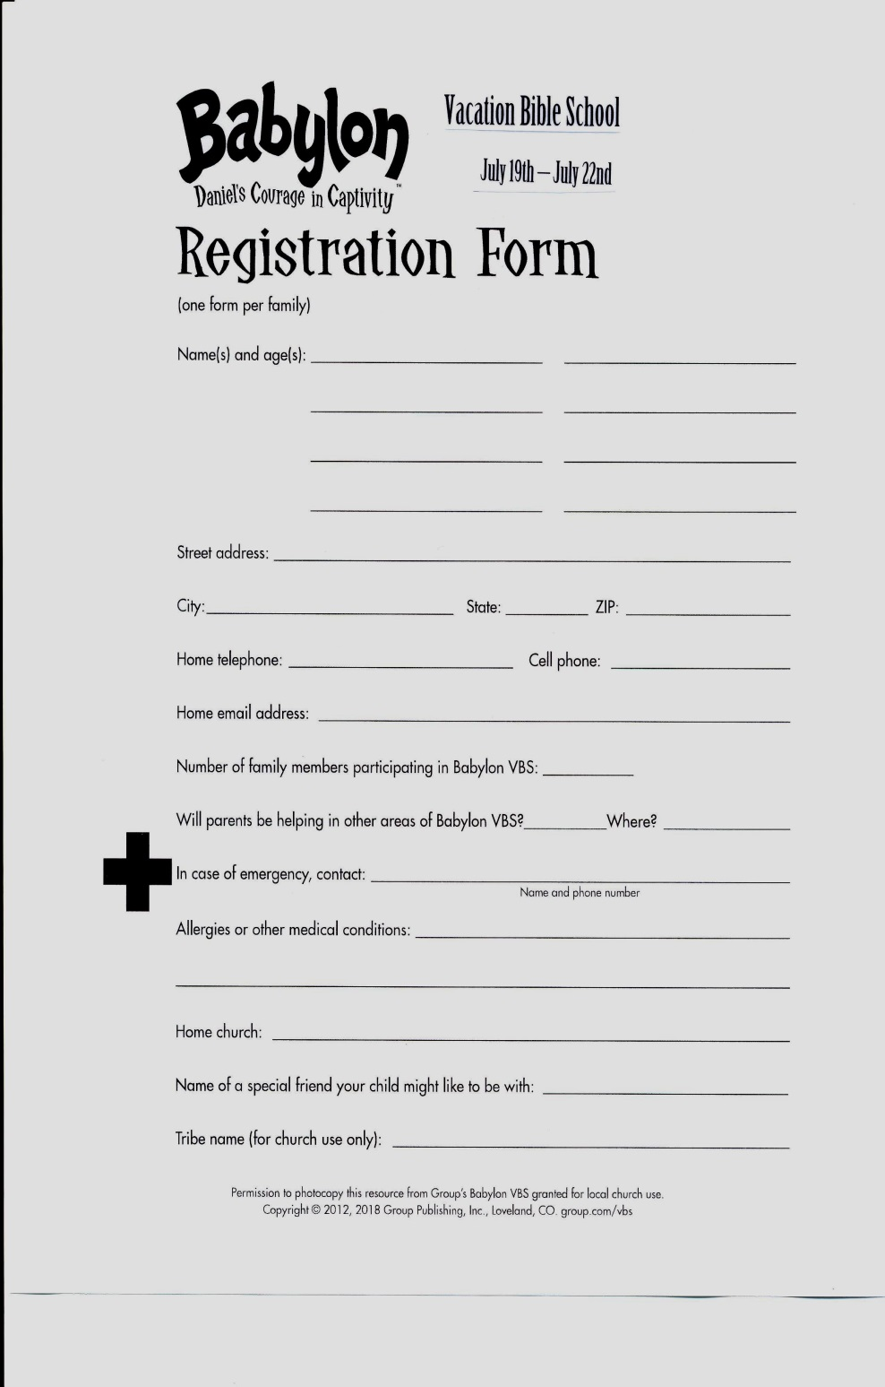
Fairview’s God & Country Celebration
Saturday, June 30th

Games – 4:00 p.m.
Band Concert – 5:00 p.m.
Cookout – 6:00 p.m.

Make plans to come and bring a friend!

2019 Daily Text Order Form

It’s hard to believe, but now is the time to order your 2019 Daily Texts! In order for our members to get the Early Bird discount, you need to place your order no later than Sunday, July 22nd, 2018. Orders will not be accepted after July 22nd, so be sure to order early to get it in. We order only a few extra books; so if you plan to purchase these publications through Fairview, please fill out the order form below and place it in the offering plate or turn in to the Church Office.

Please indicate below how many of each you want to order:

Paperback Daily Texts ($8.93)

Hard Cover Daily Texts ($12.75)

Large Print Daily Texts ($11.05)

2019 Directory & Statistics -- special price of $5.00 if
purchased with your Daily Text

2019 Directory & Statistics – $8.50 if purchased alone

Total Number of Books
Pre-payment is appreciated.

Name

Phone Number

If you order Daily Texts, please be sure you pick them up.

