Sixth Sunday after Pentecost
July 1, 2018, 10:00 AM

Watchword of the Week:
The steadfast love of the Lord never ceases His mercies
never come to an end.
Lamentations 3: 22

♥Prelude Battle Hymn of the Republic Arr. Smith and Hustad

Welcome and Announcements Rev. Scott Venable

Prayers of the People/Pastoral Prayer

Call to Worship

You are the God of all nations,
We give You thanks and praise for who we have become in You.
You are the God of all peoples,
We welcome all in the name of Christ who first welcomed us.
You are the God of all things,
Nations rise, and nations fall, but You are the same God yesterday, today, and forever. We come together to worship You. Amen.

*Liturgy for National Occasions, page 139
(Following the Liturgy, please greet those around you in the Name of Christ.)

Giving of Tithes and Offerings to the Lord
Prayer of Dedication
Anthem Heal Our Land with America, the Beautiful Arr. Fettke

If my people will humble themselves, humble themselves and pray; if they seek my face and humble themselves, and turn from their wicked ways. I will hear from heaven, and forgive their sin. I will hear from heaven, and heal their land.

Lord, heal our land; Father, heal our land. Hear our cry and turn our nation back to You. Lord, heal our land; hear us, O Lord, and heal our land. Forgive our sin and heal our broken land.

Lord, we bow our knee, we humble ourselves, humble ourselves and pray; Lord, we seek Your face, we humble ourselves, and turn from our wicked ways. Father, in Your mercy, forgive our sin. Father, in Your mercy, come heal our land.
O beautiful for men of faith who founded this great land; proclaimed for us, “In God we trust,” and held to God’s strong hand. America! America! God shed His grace on thee till lives confess His righteousness from sea to shining sea. Heal our land, Father, heal our broken land.

“Heal Our Land with America the Beautiful”,
Words and Music by Tom and Robin Brooks, Arr. by Tom Fettke
©1988 Integrity’s Hosanna! Music/ASCAP & Integrity’s Alleluia/SESAC
CCLI License #751334

*Doxology

Children’s Message Kimberly Brendle

Reading of God’s Word Dorcas Hauser
Lamentations 3: 22-33 (page 669, LP page 1279)
2 Corinthians 8: 7-15 (page 941, LP page 1802)

* Hymn 705 My Faith Looks Trustingly

Sermon Rev. Venable
Faith that Makes Us Whole
Mark 5: 21-43 (page 816, LP page 1559)

*Hymn 698 Our Forebears Lived By Faith

*Benediction

*Postlude Our Country Arr. Whitworth

♥Please sign the Friendship Register at the end of your row and pass it down. If you would like information about our activities or becoming a member of Fairview, please indicate your wish in the appropriate space.
Children three years old and under may go to the Nursery.
*Please stand.

The flowers in the sanctuary today are given to the Glory of God and in loving memory of Cheri Wright from Bill Wright.

Last Sunday Attendance – 87 Sunday School – 44
Pledges/Offerings/Gifts/Other for June 24th – $5,869.61
Monthly Budget Needs $40,636.34
Monies Received Month to Date 29,462.42
Needed as of June 24th $11,173.92

Stewards of Service This Week:

Ushers: Danny Ferguson, Mollie Rascoe, David Timmons
Robin Yokley, Chris Melton
Greeters: Cynthia Faircloth and Jeanne Willard
Worship Nursery:
Sunday School Nursery: Carolyn Neal
Sound System Operator: Warren Boyer
Elder of the Month: Doris Bostian
Trustee of the Month: Steve Morgan

MEMORIALS

The Landscape Fund has received gifts in honor of Doris Bostian for the beautiful landscaping around our church. Your hard work is enjoyed by all who visit Fairview and in honor of Bill Wright for all you do around the church from the Women’s Fellowship.
The Choir Fund has received a gift in memory of Rev. John Giesler from Pat and Harry Sapp.
The Nursery Renovation has received a gift in honor of the Women’s Fellowship Executive Board from Corky and Danny Flowers.
The General Fund has received a gift in honor of the Friendship Class from Corky and Danny Flowers.

CALENDAR: JULY 1– JULY 8, 2018

Today 10:00 AM Worship
11:10 AM Sunday School
Monday 6:00 PM Back to Basics (AB)
Tuesday 10:00 AM Staff Meeting
3:00 PM TAI CHI (FH)
Wednesday Church Office Closed
Friday 8:30 AM Men’s Fellowship at K&W Healy Drive
10:00 AM Fellowship Hall in Use by Private Party
6:00 PM Back to Basics (AB)
Saturday 10:00 AM Fellowship Hall in Use by Private Party
10:30 AM Activity Building in Use for Meeting
Concerning 2018 Synod Resolutions
Sunday 9:30 AM Band Prelude
10:00 AM Worship-Holy Communion
11:10 AM Sunday School
6:00 PM Fairview Chancel Choir at Forsyth Prison

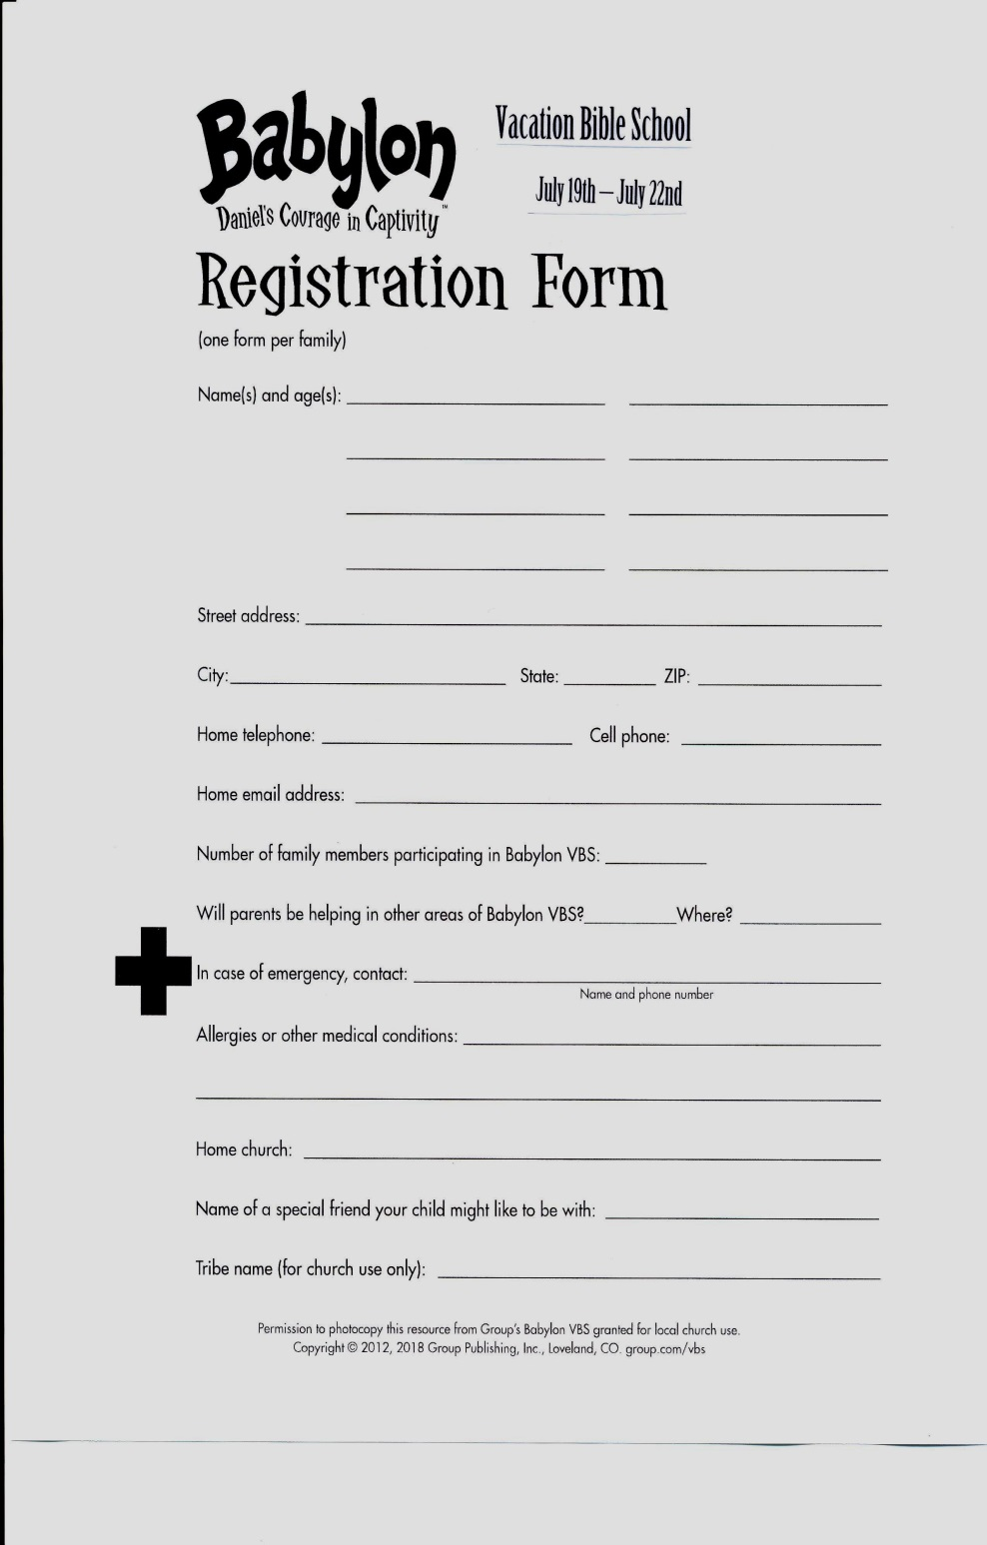

2019 Daily Text Order Form

It’s hard to believe, but now is the time to order your 2019 Daily Texts! In order for our members to get the Early Bird discount, you need to place your order no later than Sunday, July 22nd, 2018. Orders will not be accepted after July 22nd, so be sure to order early to get it in. We order only a few extra books; so if you plan to purchase these publications through Fairview, please fill out the order form below and place it in the offering plate or turn in to the Church Office.

Please indicate below how many of each you want to order:

Paperback Daily Texts ($8.93)

Hard Cover Daily Texts ($12.75)

Large Print Daily Texts ($11.05)

2019 Directory & Statistics -- special price of $5.00 if
purchased with your Daily Text

2019 Directory & Statistics – $8.50 if purchased alone

Total Number of Books
Pre-payment is appreciated.

Name

Phone Number

If you order Daily Texts, please be sure you pick them up.

