Fifth Sunday After the Epiphany
February 9, 2020, 10:00 AM

Watchword of the Week:
For I decide to know nothing among you except Jesus Christ,
and him crucified.
1 Corinthians 2: 2

♥Prelude Be Thou My Vision Arr. Whitworth

Welcome and Announcements Rev. Jeff Coppage

Call to Worship God Himself Is with Us ARNSBERG

Prayers of the People/Pastoral Prayer

*Liturgy: Celebration, Page 43 Kathy Cooke
(Following the Liturgy, please greet those around you in the Name of Christ.)

Giving of Tithes and Offerings to the Lord
Prayer of Dedication
Anthem Speak, O Lord Arr. McDonald

Speak, O Lord, as we come to You to receive the food of Your Holy Word; take Your truth, plant it deep in us;
shape and fashion us in Your likeness, that the light of Christ may be seen today in our acts of love and our deeds of faith.
Speak, O Lord, and fulfill in us all Your purposes for Your glory.
Teach us, Lord, full obedience, holy reverence, true humility; test our thoughts and our attitudes in the radiance of Your purity. Cause our faith to rise; cause our eyes to see Your majestic love and authority. Words of pow'r that can never fail, let their truth prevail over unbelief.
Speak, O Lord, and renew our minds; help us grasp the heights of Your plans for us. Truth unchanged from the dawn of time that will echo down through eternity. And by grace we'll stand on Your promises, and by faith we'll walk as You walk with us. Speak, O Lord, till Your church is built and the earth is filled with Your glory.

“Speak, O Lord”, Words and Music by Keith Getty
and Stuart Townend; arranged by Mary McDonald
©2008 Thank You Music
CCLI License #751334

Doxology

Children’s Message Linda Mathers
Reading of God’s Word Ken Hauser
Isaiah 58: 1-12 (page 600, LP page 1152)
1 Corinthians 2: 1-16 (page 927, LP page 1773)

*Hymn 751 God of Grace and God of Glory

Sermon Rev. Coppage
“The Power of God’s Mysterious Ways”
Matthew 5: 13-20 (page 786, LP page 1501)

*Hymn 608 O Jesus, My Lord

*Postlude O for a Thousand Tongues to Sing Arr. Kelley

Sunday School classes follow worship each Sunday.

♥Please sign the Friendship Register at the end of your row and pass it down. If you would like information about our activities or becoming a member of Fairview, please indicate your wish in the appropriate space.

Children three years old and under may go to the Nursery.

*Please stand.

During cold and flu season, please be understanding if your neighbor prefers not to shake hands during our greeting time. Thank you!

The flowers today are given to the Glory of God and in honor of Connie Davis on her 95th birthday on February 7th by Kathy, Kristen, Jerry and Thad.

The Organ Fund has received gifts in memory of Keith Bess from WF Circle # 2, Brenda and John Miller, and Ruby Gentle.

Stewards of Service This Week:

Ushers: Lindsay Tise, Jerry Byerly, Jeannie Willard, Kevin Krause
Greeters: Pat Sapp and Cynthia Faircloth
Worship Nursery: Terri Barringer
Sunday School Nursery: Eugenia Ivy
Elder of the Month: Carolyn Neal
Trustee of the Month: Bill Wright

Thank you to my church family for your thoughts, prayers, cards and acts of kindness that were shown to me during his surgery and recovery.
Henry Hilker.

Last Sunday Attendance – 89 Sunday School - 51
Pledges/Offerings/Gifts/Other for February 2 – $ 8,947.00
Monthly Budget Needs $ 28,829.67
Monies Received Month to Date $ 8,947.00
Needed as of February 2 $ 19,882.67

CALENDAR: FEBRUARY 9 – FEBRUARY 16

Today 8:00 AM Chapel in Use by Quaker Church
10:00 AM Worship
11:10 AM Sunday School
Monday 1:00 PM Painting Class informational Meeting (CR)
6:00 PM Back to Basics (AB)
7:00 PM Jt. Bd. (P) with Elders (P) and Trustee (CR)
Meetings to Follow
Wednesday 12:00 PM Wednesday Lunch and Bible Study (FH)
“Journey with John”
Friday 6:00 PM Back to Basics (AB)
Sunday 8:00 AM Chapel in Use by Quaker Church
10:00 AM Worship
11:10 AM Sunday School
4:30 PM Band Practice (C)

Staff & Ministry Areas of Fairview
Office Phone: 336-768-5629; Kitchen Phone: 336-768-1958
E-mail: fmc@fairviewmoravianchurch.org
Website: http://www.fairviewmoravianchurch.org
Office Hours: Monday–Thursday, 9:00 AM–4:30 PM

Rev. Jeff Coppage, Pastor Marshall Mathers, Vice-Chair, Elders
Lewis Phillips, Music Director/Pastoral Assistant Gay Nell Hutchens, Chair, Trustees
Patricia Rau, Treasurer/Administrative Assistant Rod Back, Vice-Chair, Trustees
Nancy Morgan, Choir Accompanist Van Krause, Band Director

Fairview Moravian Church

February 9, 2020
6550 Silas Creek Parkway
Winston-Salem, NC 27106

336-768-5629

www.fairviewmoravianchurch.org

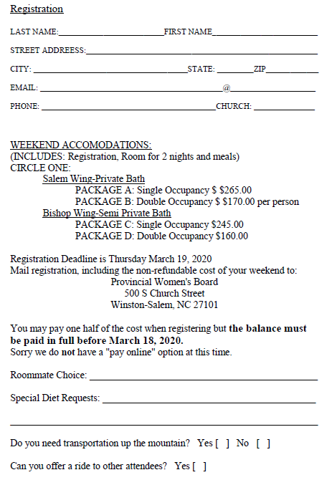

Friday April 24- Sunday April 26, 2020

Retreat Facilitator: Sister Donna Hurt

Laurel Ridge Camp and Conference Center
Higgins Lodge
124 Pendry Dr. Laurel Springs, NC 28644

The Spiritual Life Retreat is an opportunity for all women in the Province to gather for spiritual renewal and fellowship. The goal for the retreat is for participants to leave the weekend rested, renewed in her faith journey, and with new friends in our sisterhood.

Let the word of Christ dwell in you richly; teach and admonish one another in all wisdom; and with gratitude in your hearts sing psalms, hymns, and spiritual songs to God.
Colossians 3:16

For further information please contact:
The Provincial Women's Board
336.722.4911 pwbmcsp@gmail.com

500 S. Church St, Winston-Salem, NC 27101

Please let Cynthia Faircloth know if you are interested in going.
If we have enough interest from the church, we may take the
bus to Laurel Ridge for the retreat.

