Sixth Sunday After the Epiphany
February 16, 2020, 10:00 AM

Watchword of the Week:
Choose life so that you and your descendants may live, loving the Lord your God, obeying him, and holding fast to him.
Deuteronomy 30: 19, 20

♥Prelude How Firm a Foundation Arr. Harris

Welcome and Announcements Rev. Jeff Coppage

Call to Worship Surely the Presence of the Lord WOLFE

Prayers of the People/Pastoral Prayer

*Liturgy: Christian Unity, Page 122 Melissa Thompson
(Following the Liturgy, please greet those around you in the Name of Christ.)

Giving of Tithes and Offerings to the Lord
Prayer of Dedication
Anthem A Clean Heart Harlen

Create in me a clean heart, O God. Create in me a clean heart. Renew my spirit, renew my spirit. Create in me a clean heart. A heart that’s free to give as you have giv’n to me; a heart that’s free to love as you have loved me; a heart that really cares; a heart that always shares. Create in me a clean heart.

“A Clean Heart”, Text adapted from Psalm 51
And Music by Benjamin Harlan
©1992 Glory Sound
CCLI License #751334

Doxology

Children’s Message Kathy Cooke

Reading of God’s Word Doris Bostian
Deuteronomy 30: 15-20 (page 163, LP page 320)
1 Corinthians 3: 1-9 (page 927, LP page 1774)

*Hymn 494 Breathe on Me, Breath of God

Sermon Rev. Coppage
“Ready for Solid Food”
Matthew 5: 21-37 (page 786, LP page 1502)

*Hymn 519 Come, Let Us All with Gladness Raise

*Postlude All the Way My Savior Leads Me Lowry

Sunday School classes follow worship each Sunday.

♥Please sign the Friendship Register at the end of your row and pass it down. If you would like information about our activities or becoming a member of Fairview, please indicate your wish in the appropriate space.

Children three years old and under may go to the Nursery.

*Please stand.

During cold and flu season, please be understanding if your neighbor prefers not to shake hands during our greeting time. Thank you!

The chancel flowers are given today to the Glory of God and in loving memory of Melvin Fulp by Betty Fulp and Melissa Thompson.

The Congregation was saddened by the loss of one of our members, Judy Snyder, on Sunday, February 9th. Please keep Opal Miller, John Snyder and the Snyder family in your thoughts and prayers.

Stewards of Service This Week:

Ushers: Dick Joyce, Jean Townsend, Sharlene Medley, Rick Vaughn
Greeters: Ellen and Dick Joyce
Worship Nursery: Open
Sunday School Nursery: Phyllis Footland
Elder of the Month: Carolyn Neal
Trustee of the Month: Bill Wright
Sound Technician: Alan Millikan

Last Sunday Attendance – 81 Sunday School - 41
Pledges/Offerings/Gifts/Other for February 9 – $ 3,334.00
Monthly Budget Needs $ 28,829.67
Monies Received Month to Date $12,281.00
Needed as of February 9 $ 16,548.67

CALENDAR: FEBRUARY 16 – FEBRUARY 23

Today 8:00 AM Chapel in Use by Quaker Church
10:00 AM Worship
11:10 AM Sunday School
12:45 PM Visitation for Snyder Family (P)
2:00 PM Funeral Service Judy Snyder (S)
Monday 10:00 AM Water Color Painting Class (CR)
6:00 PM Back to Basics (AB)
7:00 PM WF Circle # 3 (P)
Tuesday 10:00 AM Private Group Meeting (AB)
1:00 PM Private Group Meeting (CR)
Wednesday 12:00 PM Wednesday Lunch and Bible Study (FH)
“Journey with John”
5:45 PM Handbell Practice (HR)
7:00 PM Choir Practice (S)
Friday 5:00 PM Private Party Set Up in Fellowship Hall
6:00 PM Back to Basics (AB)
Saturday 8:00 AM Private Party in Fellowship Hall
Sunday 8:00 AM Chapel in Use by Quaker Church
10:00 AM Worship-Stella Brendle Speaker
11:10 AM Church Council
4:30 PM Band Practice (C)

Staff & Ministry Areas of Fairview
Office Phone: 336-768-5629; Kitchen Phone: 336-768-1958
E-mail: fmc@fairviewmoravianchurch.org
Website: http://www.fairviewmoravianchurch.org
Office Hours: Monday–Thursday, 9:00 AM–4:30 PM

Rev. Jeff Coppage, Pastor Marshall Mathers, Vice-Chair, Elders
Lewis Phillips, Music Director/Pastoral Assistant Gay Nell Hutchens, Chair, Trustees
Patricia Rau, Treasurer/Administrative Assistant Rod Back, Vice-Chair, Trustees
Nancy Morgan, Choir Accompanist Van Krause, Band Director

Fairview Moravian Church

February 16, 2020
6550 Silas Creek Parkway
Winston-Salem, NC 27106

336-768-5629

www.fairviewmoravianchurch.org

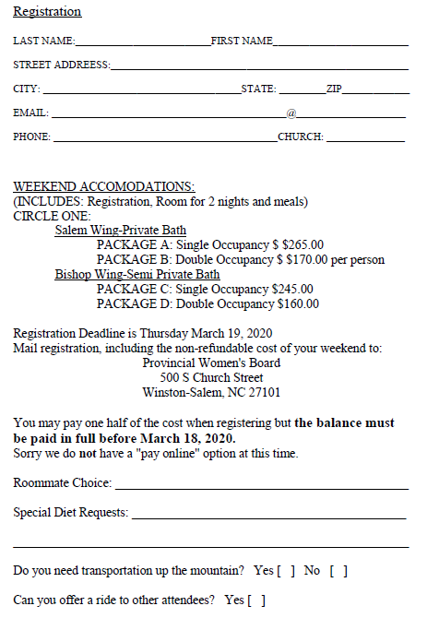

Friday April 24- Sunday April 26, 2020

Retreat Facilitator: Sister Donna Hurt

Laurel Ridge Camp and Conference Center
Higgins Lodge
124 Pendry Dr. Laurel Springs, NC 28644

The Spiritual Life Retreat is an opportunity for all women in the Province to gather for spiritual renewal and fellowship. The goal for the retreat is for participants to leave the weekend rested, renewed in her faith journey, and with new friends in our sisterhood.

Let the word of Christ dwell in you richly; teach and admonish one another in all wisdom; and with gratitude in your hearts sing psalms, hymns, and spiritual songs to God.
Colossians 3:16

For further information please contact:
The Provincial Women's Board
336.722.4911 pwbmcsp@gmail.com

500 S. Church St, Winston-Salem, NC 27101

Please let Cynthia Faircloth know if you are interested in going.
If we have enough interest from the church, we may take the
bus to Laurel Ridge for the retreat.

