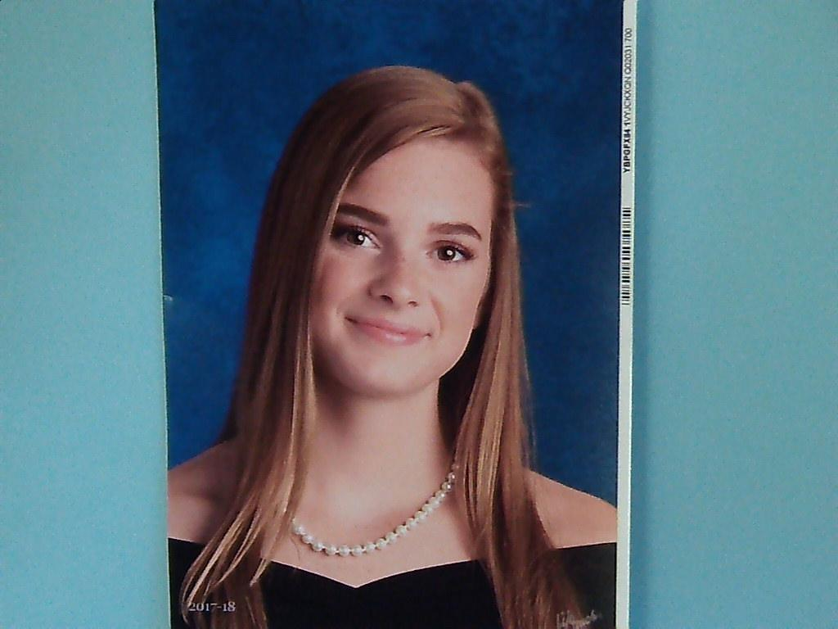
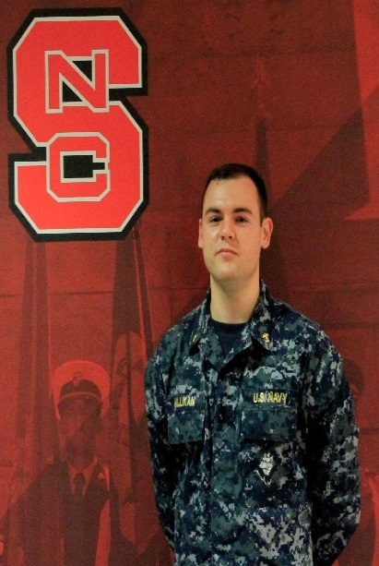
Jeremiah Alan Millikan is the son of Dianne and Alan Millikan and the grandson of Lucy Millikan and the late Benny Millikan and Ruth Morgan and the late Richard Morgan. He has a twin brother, Daniel. Jeremiah graduated on May 12th from North Carolina State University with a Bachelor of Science degree in Textile Technology and a minor in Naval Science. He was commissioned as an Ensign in the United States Navy and has orders to report to USS BAINBRIDGE (DDG 96) stationed in Norfolk, Virginia to train to become a Surface Warfare Officer.

To Our Graduates

Today we join with heaven as we celebrate and give thanks for every student here. Thank you that each one is unique and brimming with potential.
Thank you for leading them in their learning, for keeping them safe as they studied, and for watching over them in their final exams.
We pray that they may all feel proud this day and enjoy sharing their achievements with family and friends.
May today be a memory that burns bright within them as they embark on life’s great adventure.

Lillian Virginia Brendle will graduate from North Forsyth High School on Saturday, June 9th. Lilly is the daughter of Kimberly and Jody Brendle. She has two older brothers, Logan and Aubrey and a younger sister, Stella. Lilly is an Honors Graduate, a Crosby Scholar, a member of the National Honor Society, Dance Honor Society, Tri-M Music Honor Society, and an All-State Chorus participant for 2018. She is currently enrolled in the Bachelor of Science transfer program at Forsyth Technical Community College. She plans to pursue a career as a flight attendant.

Seth Alexander Hauser is the son of Kathryn and Sam Hauser and the grandson of Dorcas and Ken Hauser. He has a younger brother, Jacob. Seth received his Bachelor of Arts degree in Economics with a Credential in Quantitative Financial Economics, a Minor in Spanish for the Business Profession and a Minor in Philosophy, Politics and Economics from The University of North Carolina at Chapel Hill on Sunday, May 13th. He will begin work in July for the United Bank of Switzerland in Charlotte.

